**Payroll Management System**

A Minor Project

**Submitted in Partial fulfillment of the requirements for the degree of Bachelor of Engineering in Information Technology**

Submitted to



Rajiv Gandhi Proudyogiki Vishwavidhyalaya, Bhopal (M.P.)

Submitted By:

**Lucky Jain [0126IT131052]**

**Piyush Malviya [0126IT131064]**

**Smita Rai [0126IT131089]**

Under the Guidance of

**Mr. Avinash Sharma**

Assistant Professor, IT

**Department of Information Technology**



**ORIENTAL COLLEGE OF TECHNOLOGY, BHOPAL**

**Approved by AICTE New Delhi & Govt. of M.P.**

**Affiliated to Rajiv Gandhi Proudyogiki Vishwavidhyalaya, Bhopal (M.P.)**

**Session: July-December,2016**

|  |  |
| --- | --- |
| H:\mono.jpg | **ORIENTAL COLLEGE OF TECHNOLOGY, BHOPAL**  **Approved by AICTE New Delhi & Govt. of M.P. & Affiliated to Rajiv Gandhi Proudyogiki Vishwavidhyalaya Bhopal (M.P.)**  **DEPARTMENT OF INFORMATION TECHNOLOGY** |

**CERTIFICATE**



This is to certify that the work embodied in this Minor Project entitled as **“Payroll Management System”** has been satisfactorily completed by Lucky Jain(0126IT131052), Piyush Malviya (0126IT131064), Smita Rai (0126IT131089) students of B.E, IV year, VII Sem.

It is a bonafide piece of work, carried out under my guidance in the **Information Technology, Oriental College of Technology, Bhopal** for the partial fulfillment of the **Bachelor of Engineering in** **Information Technology** degree during the academic session July-December, 2016.

|  |  |
| --- | --- |
| **Mr. Avinash Sharma**  Assistant Professor  Department, IT  OCT, Bhopal  (Project Guide) | **Prof. Roopali Soni**  Head of Department  Department of IT  OCT, Bhopal |

**CANDIDATE DECLARATION**

I hereby declare that the Minor Project work presented in the report entitled as **“Payroll Management System”** submitted in the partial fulfillment of the requirements for the award of the degree of Bachelor of Engineering in Information Technology of Oriental College of Technology is an authentic record of my own work carried out at Oriental College of Technology, Bhopal.

I have not submitted the part and partial of this report for the award of any other degree or diploma.

Date: Lucky Jain (0126IT131052)

Piyush Malviya (0126IT131064)

Smita Rai (0126IT131089)

This is to certify that the above statement made by the candidate/s is correct to the best the best of my knowledge.

|  |  |  |
| --- | --- | --- |
|  |  | **Prof. Roopali Soni**  Head of Department  Department of IT  OCT, Bhopal |

**Countersigned by**

Dr. N.K.Agrawal

Director

OCT, Bhopal

**ACKNOWLEDGMENT**

I am heartily thankful to the **Oriental College of Technology** for providing me all the facilities and infrastructure to take my work to the final stage.

It is the constant supervision, moral support and proper guidance of our respected Director **Dr**. **N.K.Agrawal**  who motivated throughout the work.

I express deep sense of gratitude and respect to my learned guide **Mr. Avinash Sharma** Assistant Professor in the Department of Information Technology during all phases of my work. Without him enthusiasm and encouragement this dissertation would not have been completed. Her valuable knowledge and innovative ideas helped me to take the work to the final stage. She has timely suggested actions and procedures to follow for which I am really grateful and thankful to her.

I express my gratefulness to **Prof. Roopali Soni**, Head Information Technology Department for providing all the facilities available in the department for her continuous support, advice, and encouragement during this work and also help to extend my knowledge and proper guidelines.

I am thankful to all the faculty members and other non teaching staff of Information Technology Department for their cooperation.

Constant help, moral and financial support of my loving parents motivated me to complete the work. I express my heartily thanks to my all family members for their co-operation.

I really admire the fond support of my class-mates for their co-operation and constant help. It gives immense pleasure to acknowledge the encouragement and support extended by them. Last but not the least I am extremely thankful to all who have directly or indirectly helped me for the completion of my work.

**Lucky Jain (0126IT131052)**

**Piyush Malviya (0126IT131064)**

**Smita Rai (0126IT131089)**

**ABSTRACT**

The Payroll Management covers nearly everything needed for gathering Payroll system requirements. Payroll system is the heart of any Human Resource System of an organization. The solution has to take care of the calculation of salary as per rules of the company, income tax calculation and various deductions to be done from the salary including statutory deductions like tds (tax deducted at source) ,professional tax and provident fund deductions. It has to generate pay-slip. The purpose of this study was to develop a payroll management system to assist in the management of payroll which ease the process of doing this job than earlier pen and paper based management.Nowadays this kind of application is very essential for any small or medium sized organization. An employer, regardless of the number of workers they employ, must maintain all records pertaining to payment system digitally.This application will help to calculate the employees’salary and other relevant calculations automatically. This helps to administer of the financial record of employees' salaries, wages, bonuses, net pay, increment, conveyance, loan and deductions. The main exiting feature of our application is that it will calculatethe monthly salary automatically.

**TABLE OF CONTENTS**

|  |  |  |
| --- | --- | --- |
| **S. No** | **Contents** | **Page No.** |
|  |  |  |
|  | **List of Figures** | I |
|  | **List of Tables** | II |
|  | **List Symbols and of Abbreviations** | III |
| **1** | **Introduction** | **1-4** |
|  | 1.1 Introduction | 2 |
|  | 1.2 Need of PMS | 2-3 |
|  | 1.3 Advantages and Disadvantages of PMS | 3-4 |
|  |  |  |
| **2** | **Software Requirement Specification** | **5-9** |
|  | 2.1 Purpose | 6 |
|  | 2.2 Scope | 6 |
|  | 2.3 Abbreviations | 6 |
|  | 2.4 Feasibility Study | 6-7 |
|  | 2.5 Hardware Requirement/ Software Requirement | 7-8 |
|  | 2.6 Software Process Model Used | 8-9 |
|  |  |  |
| **3** | **System Documentation** | **10-14** |
|  | 3.1 Data Flow Diagram | 11-12 |
|  | 3.2 System Flow Chart | 13 |
|  | 3.3 Entity Relationship Diagram | 14 |
|  |  |  |
| **4** | **User Manual** | **15-25** |
|  | 4.1 Introduction and Guidelines | 16 |
|  | 4.2 Screen Layouts and Description | 17-25 |
|  |  |  |
| **5** | **Testing and Test Cases** | **26-28** |
| **6** | **Limitations** | **29-30** |
| **7** | **Conclusion and Future Work** | **31-32** |
| **8** | **Bibliography** | **33-34** |
| **9** | **References** | **35-36** |
| **10** | **Appendix** | **37-100** |

**LIST OF FIGURES**



|  |  |  |
| --- | --- | --- |
| Figure 2.1 | Software Process Model Used | 9 |
|  |  |  |
| Figure 4.1 | Shows opening window of software | 17 |

**I**

**LIST OF TABLES**

|  |  |  |
| --- | --- | --- |
| Table 5.1 | Department | 71 |
| Table 5.2 | Employee | 72 |

Table 5.3 Annual_salary 75

Table 5.4 Deduction 76

Table 5.5 Attendance 77

Table 5.6 Address 78

**II**

**LIST OF SYMBOLS AND ABBREVIATIONS**



|  |  |
| --- | --- |
| PMS | Payroll Management System |
| SQL | Structured Query Language |
| PLSQL | Procedural Structured Query Language |
| ER | Entity Relationship Diagram |
| DFD | Data Flow Diagram |
| IDE | Integrated Development Environment |

**III**

1. **INTRODUCTION**
   1. **INTRODUCTION**

It is understood that we are tired of managing thousand of odd papers, pay slips, payroll reports, and salary details and so on. Imagine that we have a payroll processing system which will generate our pay slips and payroll reports within seconds. We can help others automated your payroll system by developing a customized payroll application that suits your specific requirements.

Thus Payroll Management System is used for calculation of salary as per rules of the company.A payroll system involves everything that has to do with the payment of employees and the filling of employment taxes ,keeping track of hours ,calculating salary.

Few of the additional components are

* Basic Pay
* HRA(House Rent Allowance)
* Conveyance allowance
* Leave encashment
* Medical allowance
* LTA(Leave Travel Allowance)
* Monthly Bonus

Few of the deductions are

TDS(Tax deduced at source)

Provident Fund

Professional Tax

* 1. **NEED OF PMS**

As your organization grows, the demands on your operations ensure you hire human resources and pay them salaries based on their responsibilities and deliverables. Salaries may be fixed or based on performance or a .As the number of variables grows each time you are processing salaries, the chances of errors creeping in increase. You need to keep a track of all your employee details, their attendance, Overtime, performance linked incentives, leaves, expense reimbursements as well as various deductions mandated by labour and income tax laws such as PF, ESI, PT, and Income Tax deductions.

Your salary calculations should be efficient enough to provision for any investments that your employees make and which entitle them to various tax exemptions provided by the GovernmentThe entire process becomes extremely cumbersome and any errors have serious implications in terms of interest and penalties for delayed statutory compliances as well low employee morale.

Eventually every organization outgrows Excel. In fact, it’s never too early to move to an automated payroll system.

* 1. **ADVANTAGES AND DISADVANTAGES OF PMS**

**ADVANTAGES**

|  |  |  |  |
| --- | --- | --- | --- |
| **Ease of Use** — With Advantage, your payroll responsibility is reduced to a simple function of communication each pay period. From pay checks to tax payments to the preparation of quarterly and annual tax returns, your time investment remains minimal, allowing you to focus on what's most important...managing yourbusiness.  **Accuracy** — Keeping track of the ever-changing tax regulations can be a nightmare. Why bother? With Advantage, you have the comfort of knowing your payroll is being expertly handled. We guarantee all federal, state and local taxes will be filed and paid accurately and on time...or WE pay the penalties and interest!  **Confidentiality** — Where earnings are concerned, a breach in confidentiality can be devastating for any business. With Advantage, your payroll information is kept strictly confidential, and can be accessed only by those authorized to do so,keeping  your business safe from any potential disasters.  **Flexibility** — At Advantage, we offer a variety of payroll input options, allowing you to choose what's most convenient for you — phone, fax, or Web. We also provide comprehensive, easy-to-read management reports. And our system features extensive earnings and deductions categories, so we're flexible enough for virtually any business. Most importantly, we're prepared to grow with your company, offering a wide scope of payroll services such as direct deposit, pretax health insurance, workers' compensation premium payment, and other services that can provide great value to you and your employees.  **DISADVANTAGES**  **Constant Archiving** – Mountains of information are collected with each payroll cycle, and most payroll software programs are designed to keep up. But, that information needs to be archived continuously. And, this daily process needs the help of a human hand. In a busy operation, setting aside this particular slice of time in a workday can become a slight hassle.  **Limited Access** – In most instances, payroll software is loaded onto one computer and that data can only be accessed from that machine. This can be a hassle, especially if the payroll processing computer goes off the rails. The result could be that whole payroll process goes with it, which can cause headaches throughout the business.  **Added Weight to Overhead** – Implementing payroll software may also call for a full-time employee to take on the responsibilities of doing payroll in-house. With an added employee comes the cost of an additional salary and benefits. Also to be considered is the cost of technical support when the inevitable software glitches occur.  **Risk of Underwithholding** – The Internal Revenue Service notes that some payroll software systems are unable to distinguish additional voluntary withholding amounts from regular withholding when calculating catch-up withholding for the current tax year. This kind of glitch does not apply to all payroll software programs, but if not identified or accounted for, a business can be fined for underwitholding. | |  |  | | --- | --- | |  |  | |
|  | |

**2.SOFTWARE REQUIREMENT**

**SPECIFICATION**

* 1. **Purpose**

Main aim of developing Payroll ManagementSystem is to provide an easy way not only to automate all functionalities involved managing leaves and Payroll for the employees of Company, but also to provide full functional reports to management of Company with the details about usage of leave facility.

We are committed to bring the best way of management in the various

forms of **PMS.**We understand that **PMS**in not a product to be sold, it is a tool

to manage the inner operation of Company related to employee leave and Payroll.

* 1. **Scope**

This Application works in Multiple PC’s installed on multiple Computers but sharing same database by which users of different department can use it sitting at different locations simultaneously.

But in future we can make the Application where the database will be hosted in order to manage the all departments which will be located in different places and by keeping domain of Application as Online.

* 1. **Definitions, Acronyms, Abbreviations**
* PMS  Payroll Management System
* SQLStructured Query Language
* PLSQL Procedural Structured Query Language
* CFD Context Flow Diagram
* DFD Data Flow Diagram
* IDE Integrated Development Environment
  1. **Feasibility Study**

The overall scope of the feasibility study was to provide sufficient information to allow a decision to be made as to whether the payroll management system project should proceed and so, its relative priority in the context of the other existing payroll management system.

The feasibility study of this project had undergone through various steps which as describe as under:

* Identify the origin of the information at different level.
* Identify the expectation of user from computerized system.
* Analyze the drawback of existing system
  1. **Hardware And Software Requirement**
* **Hardware interfaces**
* Memory minimum of 1GB RAM
* Hard disk of 40 GB
* Monitor
* Mouse
* Keyboard
* **Software interfaces**
* Operating System                               Windows 7
* Front End                                           HTML
* Backend                                              ORACLE 10g(SQL,PL/SQL)

Oracle Database (commonly referred to as Oracle RDBMS or simply as Oracle) is an [object-relational database management system](https://en.wikipedia.org/wiki/Object-relational_database_management_system) produced and marketed by [Oracle Corporation](https://en.wikipedia.org/wiki/Oracle_Corporation).

**SQL** is a [special-purpose programming language](https://en.wikipedia.org/wiki/Special-purpose_programming_language) designed for managing data held in a [relational database management system](https://en.wikipedia.org/wiki/Relational_database_management_system) (RDBMS), or for stream processing in a [relational data stream management system](https://en.wikipedia.org/wiki/Relational_data_stream_management_system) (RDSMS).

Originally based upon [relational algebra](https://en.wikipedia.org/wiki/Relational_algebra) and [tuple relational calculus](https://en.wikipedia.org/wiki/Tuple_relational_calculus), SQL consists of a [data definition language](https://en.wikipedia.org/wiki/Data_definition_language), [data manipulation language](https://en.wikipedia.org/wiki/Data_manipulation_language), and [Data Control Language](https://en.wikipedia.org/wiki/Data_Control_Language). The scope of SQL includes data insert, query, update and delete, [schema](https://en.wikipedia.org/wiki/Database_schema) creation and modification, and data access control. Although SQL is often described as, and to a great extent is, a [declarative language](https://en.wikipedia.org/wiki/Declarative_programming) ([4GL](https://en.wikipedia.org/wiki/4GL)), it also includes [procedural](https://en.wikipedia.org/wiki/Procedural_programming) elements.

**PL/SQL** (**Procedural Language/Structured Query Language**) is Oracle Corporation's procedural extension for SQL and the Oracle relational database. PL/SQL is available in Oracle Database (since version 7), TimesTen in-memory database (since version 11.2.1), and IBM DB2 (since version 9.7).[[1]](https://en.wikipedia.org/wiki/PL/SQL#cite_note-1) Oracle Corporation usually extends PL/SQL functionality with each successive release of the Oracle Database.

PL/SQL includes procedural language elements such as conditions and [loops](https://en.wikipedia.org/wiki/Program_loop). It allows declaration of constants and [variables](https://en.wikipedia.org/wiki/Variable_(programming)), procedures and functions, types and variables of those types, and triggers. It can handle exceptions (runtime errors). [Arrays](https://en.wikipedia.org/wiki/Array_data_type) are supported involving the use of PL/SQL collections. Implementations from version 8 of Oracle Database onwards have included features associated with object-orientation. One can create PL/SQL units such as procedures, functions, packages, types, and triggers, which are stored in the database for reuse by applications that use any of the Oracle Database programmatic interfaces.

**2.6 Software Process Model Used**

* Prototype is a working model of software with some limited functionality.
* The prototype does not always hold the exact logic used in the actual software application and is an extra effort to be considered under effort estimation.
* Prototyping is used to allow the users evaluate developer proposals and try them out before implementation.
* It also helps understand the requirements which are user specific and may not have been considered by the developer during product design.

Following is the stepwise approach to design a software prototype:

* **Basic Requirement Identification:** This step involves understanding the very basics product requirements especially in terms of user interface. The more intricate details of the internal design and external aspects like performance and security can be ignored at this stage.
* **Developing the initial Prototype:** The initial Prototype is developed in this stage, where the very basic requirements are showcased and user interfaces are provided. These features may not exactly work in the same manner internally in the actual software developed and the workarounds are used to give the same look and feel to the customer in the prototype developed.
* **Review of the Prototype:**The prototype developed is then presented to the customer and the other important stakeholders in the project. The feedback is collected in an organized manner and used for further enhancements in the product under development.
* **Revise and enhance the Prototype:** The feedback and the review comments are discussed during this stage and some negotiations happen with the customer based on factors like , time and budget constraints and technical feasibility of actual implementation. The changes accepted are again incorporated in the new Prototype developed and the cycle repeats until customer expectations are met.

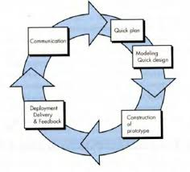

**3.SYSTEM DOCUMENTATION**

**3.1 Data Flow Diagram**

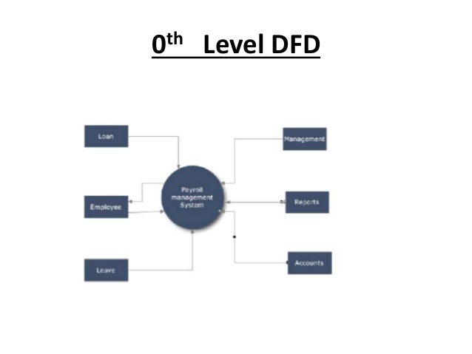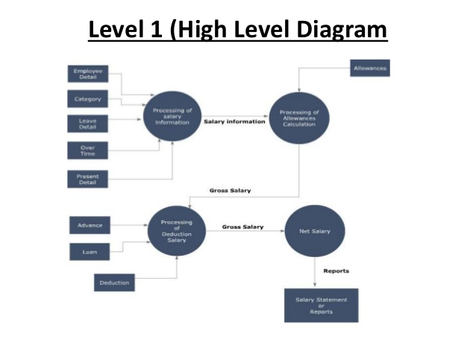

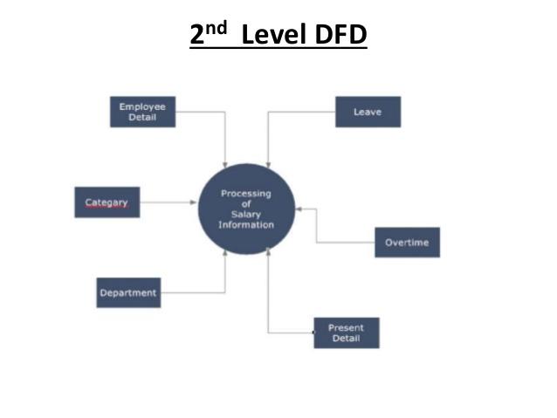

**3.2 System Flow Chart**

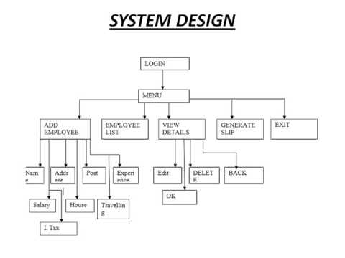

**3.3 E-R(Entity Relationship ) DIAGRAM**

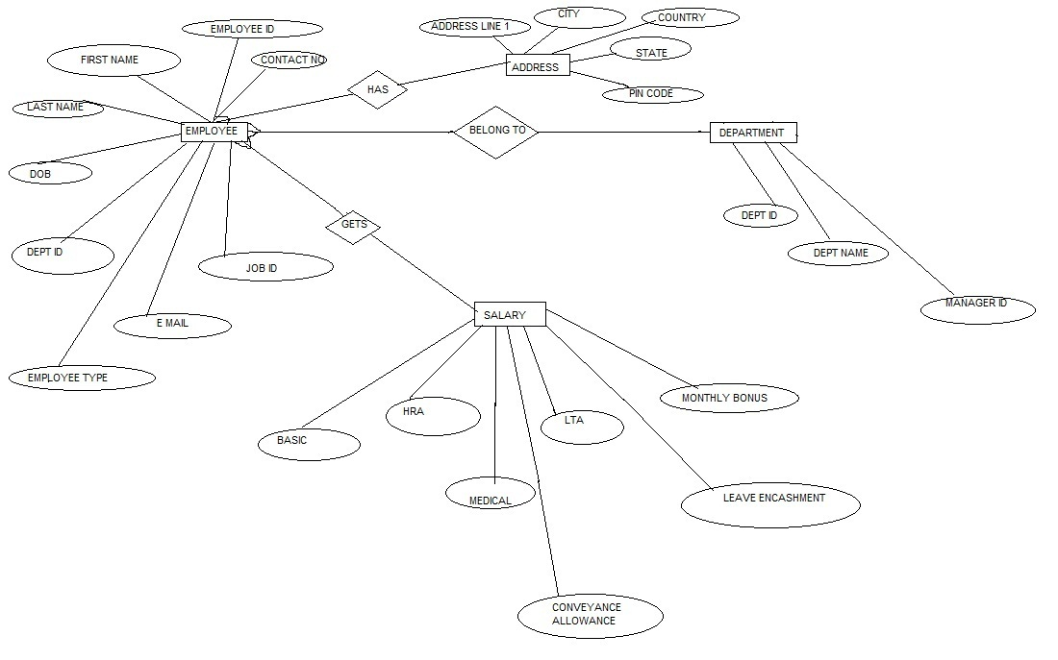

**4.USER MANUAL**

**4.1 Introduction And Guidelines**

**1** **– Introduction**

This guide is designed to be used when you wish to add your own data into Payroll Manager.

This guide covers many day-to-day payroll procedures.

**2 – Create your own data file**

Payroll Manager stores data for each tax year in a separate data file.When you are ready to enter data for your owncompany you will need to create a new data file.Click File - New - Create a new blank file from the main menu at the top of the screen.Input your Employer Name (e.g. ABC Ltd) and select the Tax Year. You will then be prompted tosave your new file and to set the Pay Dates.

**3 – Enter the Employer details**

Click Employer - Employer Details fromthe menu .Enter the Employer Name and address information

**4 – Add your employees**

Click Employees - Add new Employee fromthe menu.You will be taken through a series of screenswhere the personal, work and payment details ofeach employee can be entered. The screens thatappear depend on the answers that you giveWhen you have finished adding your employees,click Employees - Employee Details to view oramend the information.

**5– Adding or editing pay on the Pay Details screen**

Click Pay - Pay Details from the menu (or clickthe button).If the regular pay amounts were not entered whencreating the employee, you should now enter thisinformation on the Pay Details screen. If theemployee is paid a standard, regular amount thenenter this figure in the Basic Pay column. Other additions and deductions can be entered by clicking on the tabsalong the top of the PayDetails screen.

**6– Producing Payslips**

Click Pay - Employees Payslip from themenu (or click the button).Select the employee(s) you wish toproduce a payslip for

**4.2 Screen Layouts And Description**

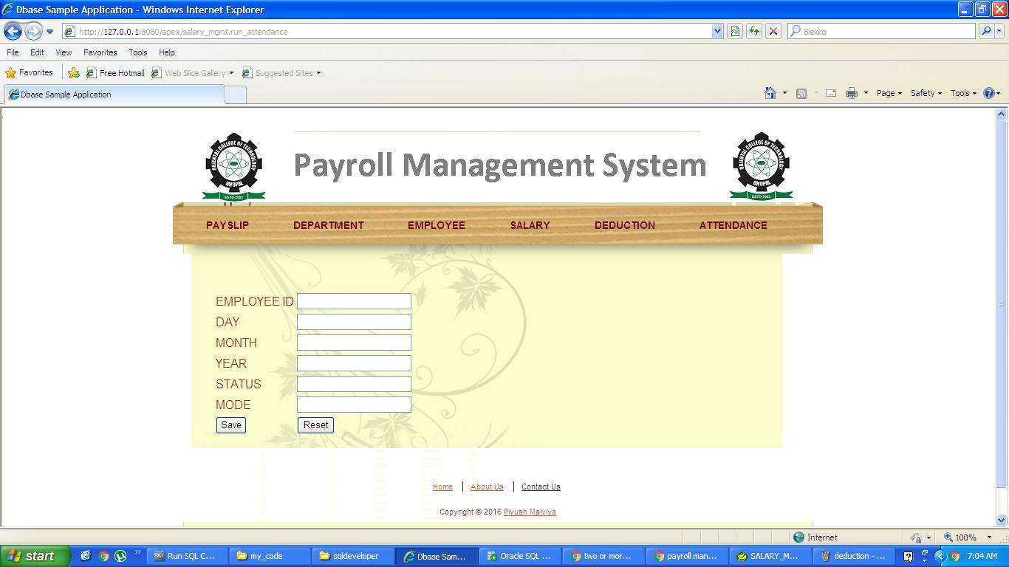

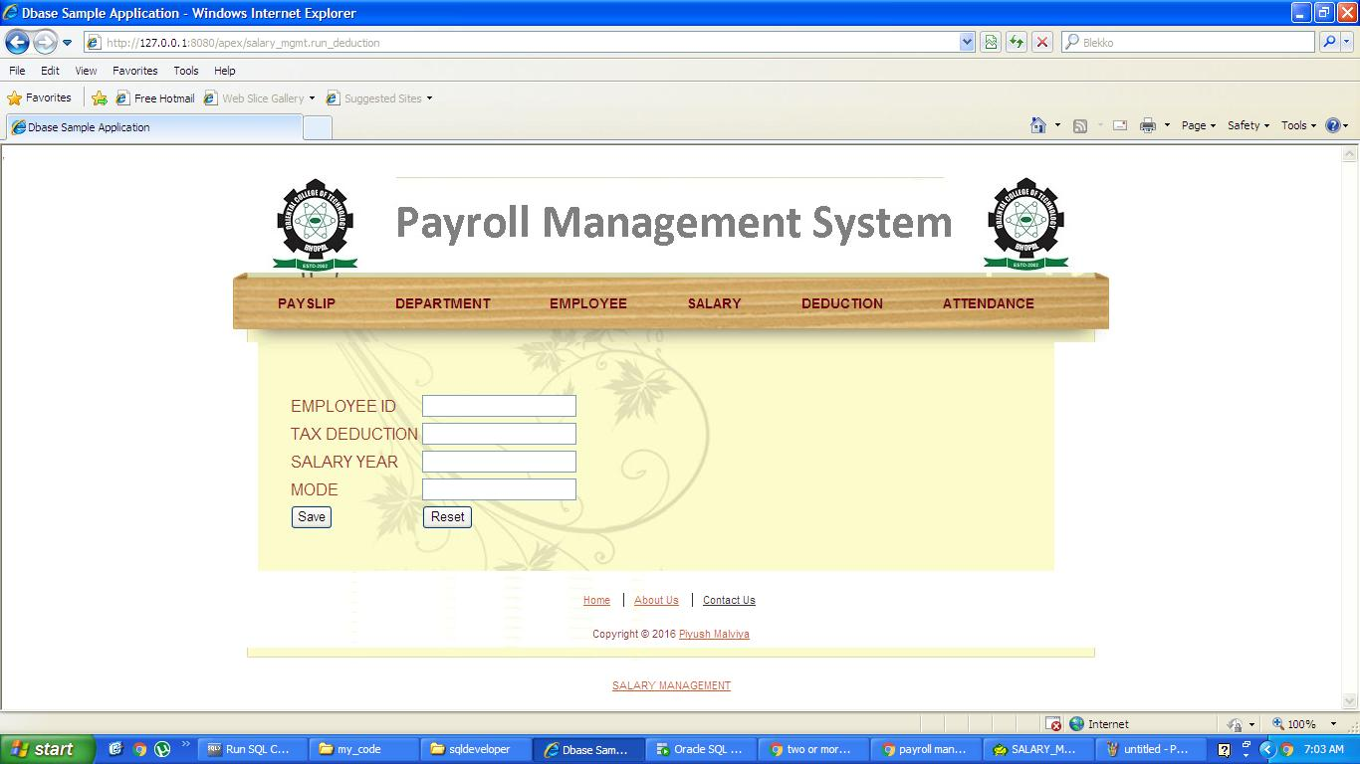

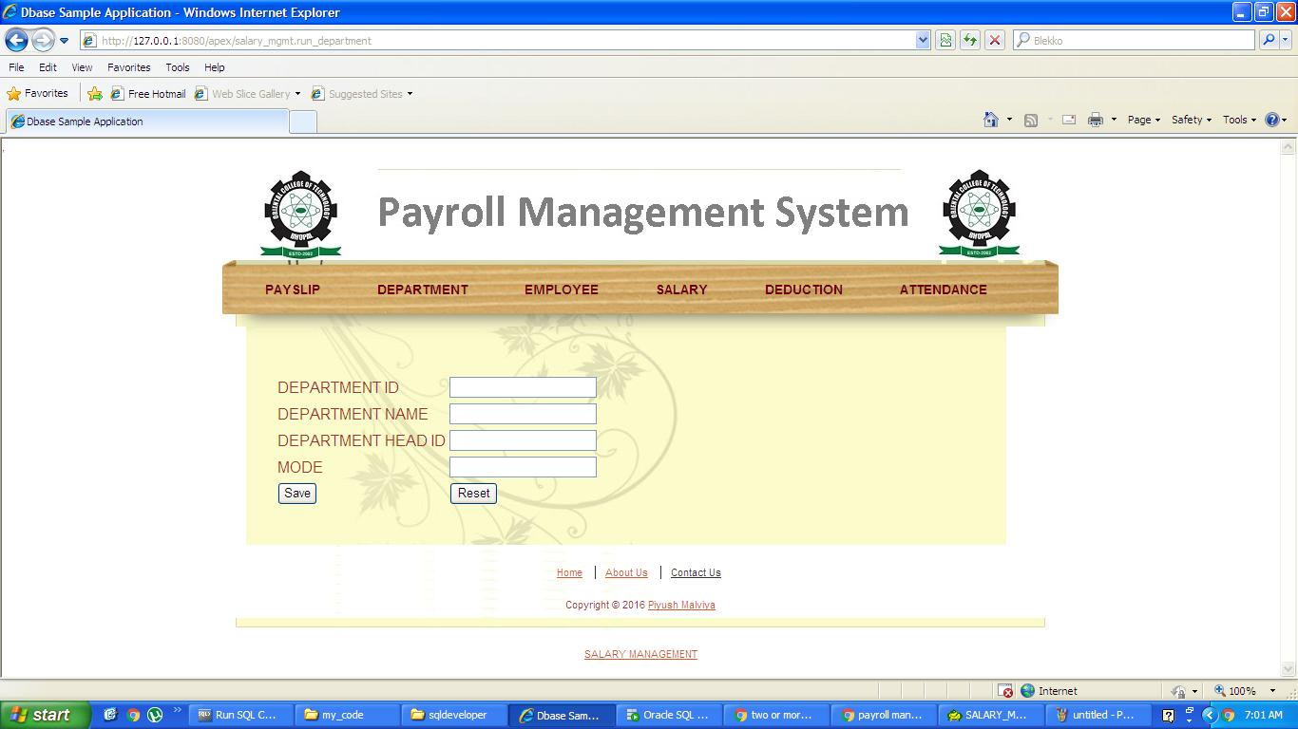

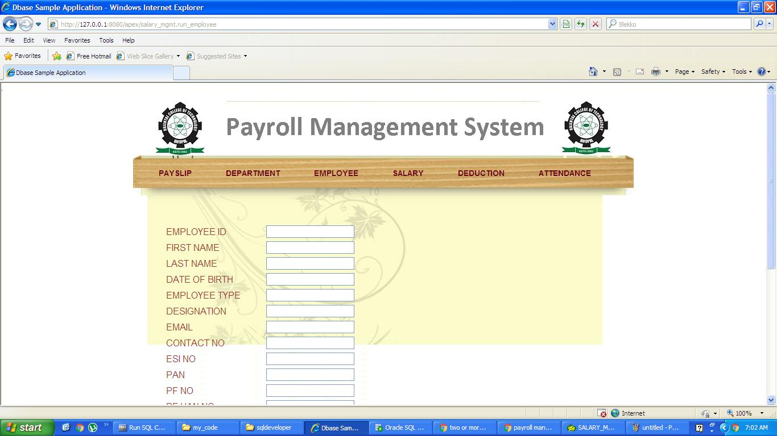

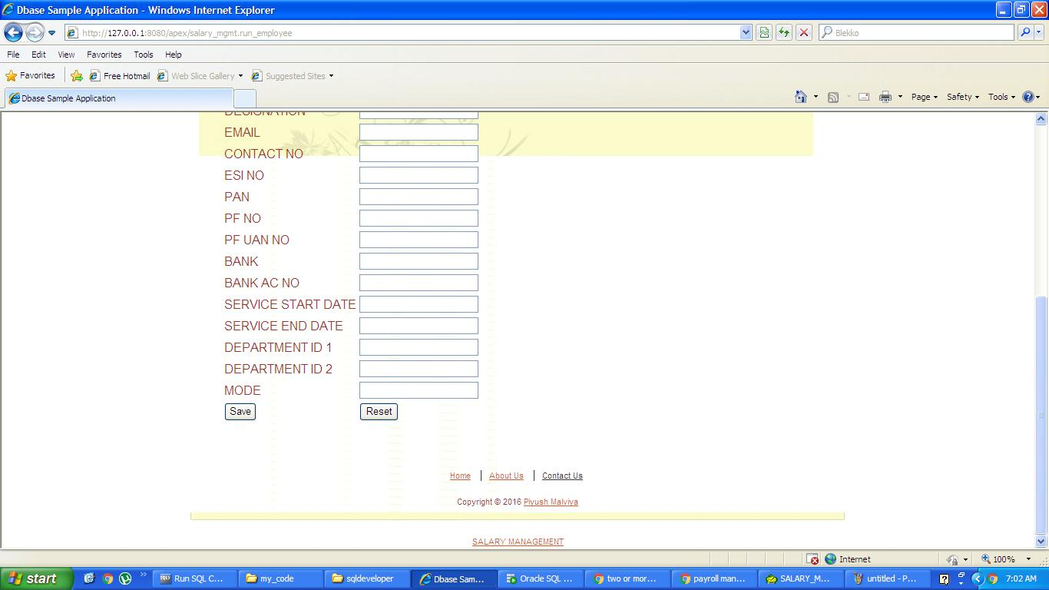

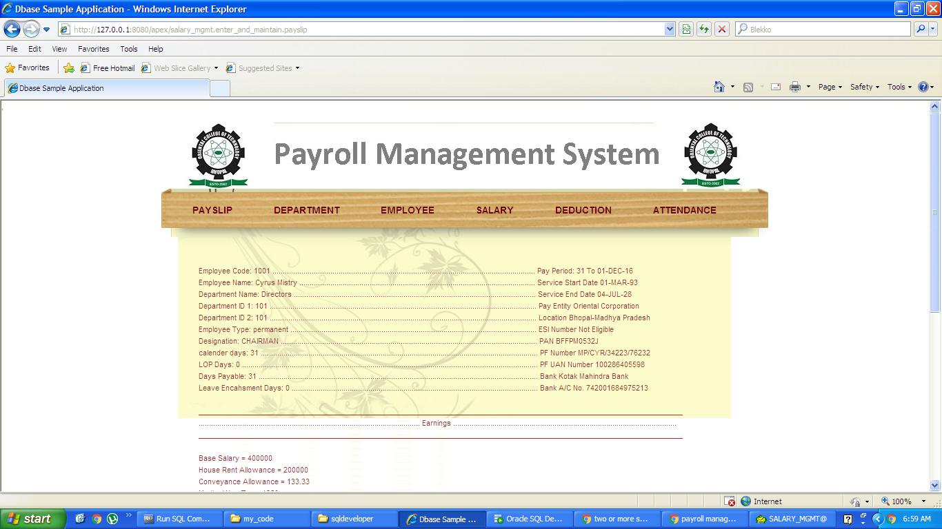

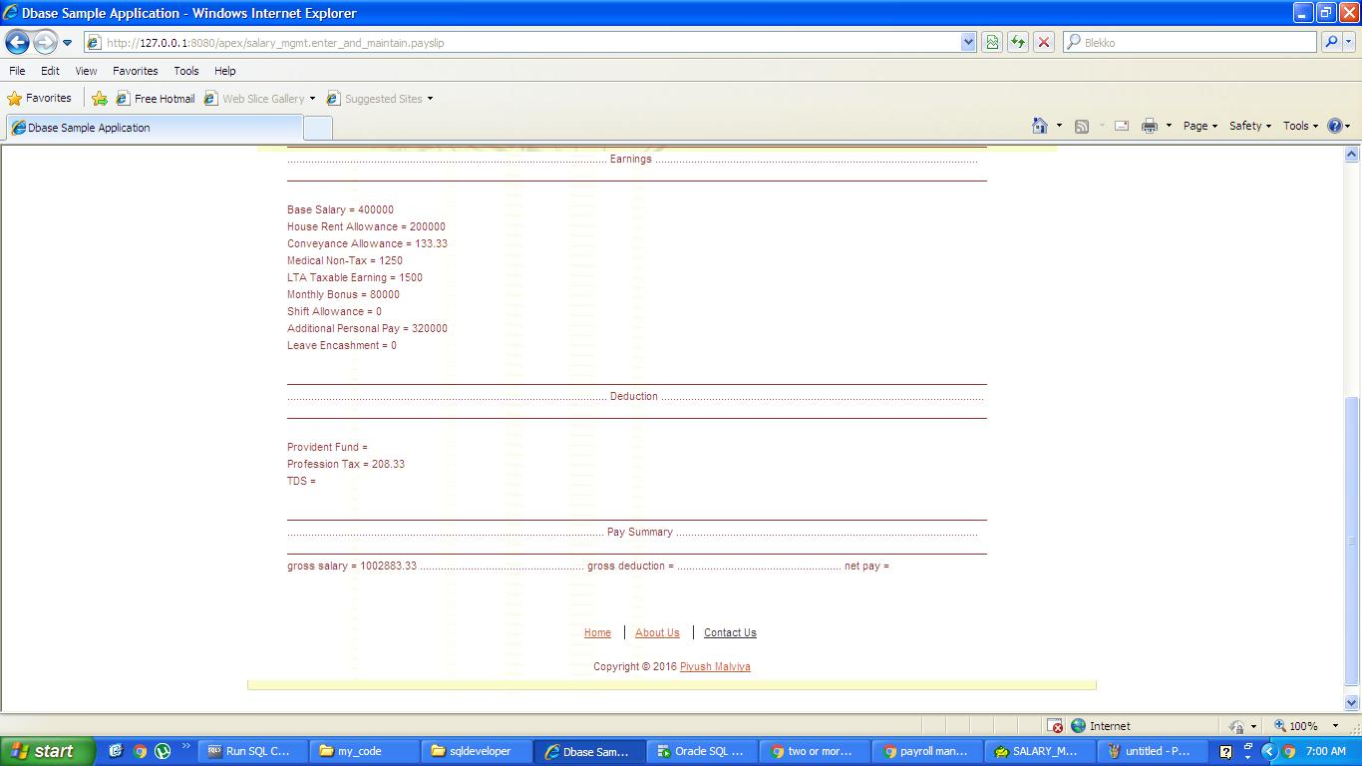

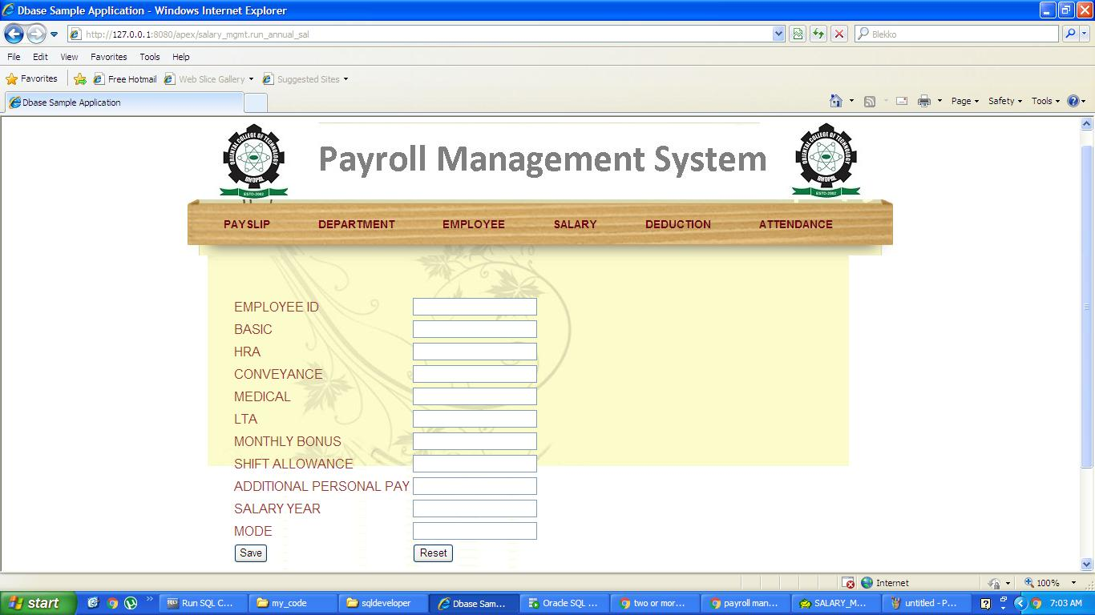

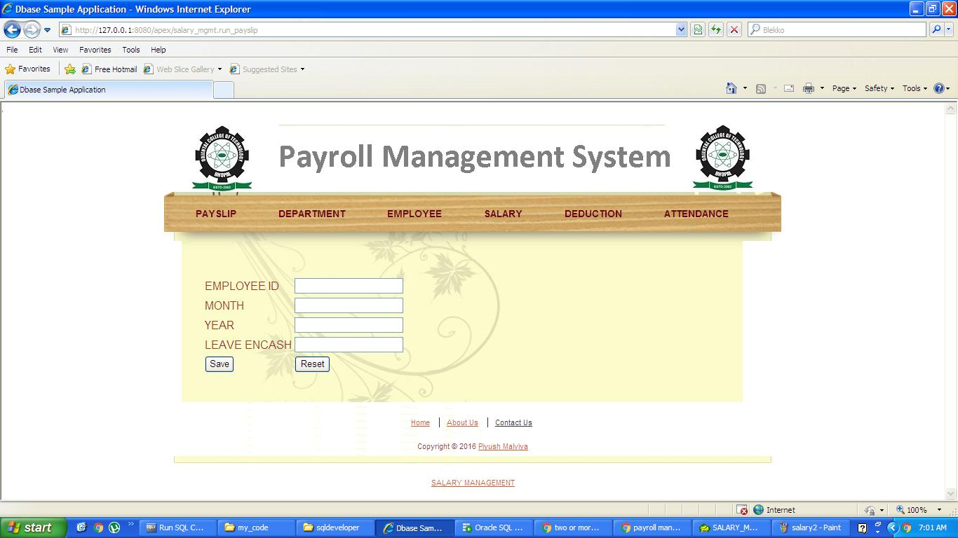

**5.TESTING AND TEST CASES**

**Test cases for Payroll System**

* Check if the ID field is system generated or requires manual input.
* Check if the ID field auto increments when next or previous button is pressed.
* Check if the ID field points to the correct employee ID.
* Check if the ID field only allows numeric input when under modification.
* Check if the ID field is editable or not if edit button is pressed.
* Check if the Employee Name field accepts text data only.
* Check the minimum required length for the Employee Name.
* Check the maximum required length for the Employee Name.
* Check if the Employee Name from the previous records points to the valid name for the employee.
* Check if the Employee Name accepts both uppercase and lowercase input.
* Check if the Employee Name does not accept any form of specialcharacter.
* Check if the DEPT field accept the department present within the company.
* Check if the DEPT field requires manual addon or if it gets auto generated.
* Check DEPT field for the minimum length of the input.
* Check DEPT field for the maximum length of the input.
* Check “No of days” field only accepts numeric data.
* Check ‘No of days” field for the maximum available input. (Ideally it should restricts for 31 days per month).
* Check Rate per day field for minimum length of the input.
* Check Rate per day field for the maximum length of the input.
* Check the salary field to verify if it is editable or not.
* Check the salary field for the calculation (no of days * per day amount).
* Check the salary field for the live input or if it requires pressing “computer” button.
* Check if the add button clears the form for the fresh input.
* Check if the add button does not open existing record.
* Check if the save button saves the data.
* Verify if the save button saves the valid data.
* Check if the update button allows the modified data to be added into the database.
* Check if the update button does not retain the old information in the database.
* Check if the delete button removes the data from the database.
* Check if the deleted data using delete button does not remain in the database.
* Check if the first button click points the form to the first record in the database.
* Check if the last button click points the form to the last record in the database.
* Check if the next button click points the form to the next available record in the database.
* Check if the previous button click points the form to the previous record from the existing open record in the database.
* Check if the exit button click results in closure of the program.
* Check if the close window button on the program exits the program.
* Check if the minimize window button for the program minimizes the program to the taskbar.
* Check if the maximize window button for the program maximizes the program to the desktop

**6.LIMITATIONS**

|  |  |  |  |
| --- | --- | --- | --- |
| **Constant Archiving** – Mountains of information are collected with each payroll cycle, and most payroll software programs are designed to keep up. But, that information needs to be archived continuously. And, this daily process needs the help of a human hand. In a busy operation, setting aside this particular slice of time in a workday can become a slight hassle.  **Limited Access** – In most instances, payroll software is loaded onto one computer and that data can only be accessed from that machine. This can be a hassle, especially if the payroll processing computer goes off the rails. The result could be that whole payroll process goes with it, which can cause headaches throughout the business.  **Added Weight to Overhead** – Implementing payroll software may also call for a full-time employee to take on the responsibilities of doing payroll in-house. With an added employee comes the cost of an additional salary and benefits. Also to be considered is the cost of technical support when the inevitable software glitches occur.  **Risk of Underwithholding** – The Internal Revenue Service notes that some payroll software systems are unable to distinguish additional voluntary withholding amounts from regular withholding when calculating catch-up withholding for the current tax year. This kind of glitch does not apply to all payroll software programs, but if not identified or accounted for, a business can be fined for underwitholding. | |  |  | | --- | --- | |  |  | |
|  | |

**7.CONCLUSION AND FUTURE WORK**

Payroll can also be used to provide valuable feedback for you business. The most obvious feedback that payroll can show a business is whether or not the business is making a profit. A precise payroll could determine that a business is losing more money then it’s bringing in because it is spending too much on paying employees. If that’s the scenario, the business may have to consider laying off some of it’s employees so that it can become more profitable.

Every business owner must have an accurate and consistent payroll so that they can pay employees correctly, withhold the right amount of taxes, and have a better understanding of their cash flow.

**8.BIBLIOGRAPHY**

* PL/SQL Packages and Types Reference
* Oracle Database 10g The Complete Reference

**9.REFERENCES**

* [www.safaribooksonline.com](http://www.safaribooksonline.com)
* [www.relationaldbdesign.com](http://www.relationaldbdesign.com)
* [www.google.com](http://www.google.com)

**10.APPENDIX**

**enter_and_maintain_annual_salary**

CONNECT salary_mgmt/dbase@xe

CREATE OR REPLACE PROCEDURE enter_and_maintain_annual_sal(

p_employee_id IN NUMBER,

p_basic IN NUMBER,

p_hra IN NUMBER, --50% of basic

p_conveyance IN NUMBER, --Rs.1500*12 per year

p_medical IN NUMBER, --15k per year

p_lta IN NUMBER, --20k per year

p_monthly_bonus IN NUMBER, --20% of basic

p_shift_allowance IN NUMBER, --Rs.0

p_additional_personal_pay IN NUMBER, --80% of basic

p_salary_year IN NUMBER,

p_mode IN VARCHAR2)

AS

v_old_basic NUMBER(10);

v_old_hra NUMBER(10,2); --50% of basic

v_old_conveyance NUMBER(10,2); --Rs.1500*12 per year

v_old_medical NUMBER(10,2); --15k per year

v_old_lta NUMBER(10,2); --20k per year

v_old_monthly_bonus NUMBER(10,2); --20% of basic

v_old_shift_allowance NUMBER(10,2); --Rs.0

v_old_additional_personal_pay NUMBER(10,2); --80% of basic

v_employee_count NUMBER(10); --need to use count for all foreign keys to check integrity constraint

v_status NUMBER(10);

BEGIN

page_formatting('BEFORE');

v_status :=0;

SELECT COUNT(*)

INTO v_employee_count

FROM employee

WHERE employee_id =p_employee_id;

IF v_employee_count=1 THEN

v_status :=1;

END IF;

IF v_status =1 THEN

IF lower(p_mode)='insert' THEN

INSERT

INTO annual_salary

(

employee_id,

basic,

hra,

conveyance,

medical,

lta,

monthly_bonus,

shift_allowance,

additional_personal_pay

)

VALUES

(

employee_id_seq.nextval,

p_basic,

p_hra, --50% of basic

p_conveyance, --Rs.1500*12 per year

p_medical, --15k per year

p_lta, --20k per year

p_monthly_bonus, --20% of basic

p_shift_allowance, --Rs.0

p_additional_personal_pay --80% of basic

);

HTP.P('Record added successfully');

ELSIF lower(p_mode)='update' THEN

SELECT basic,

hra,

conveyance,

medical,

lta,

monthly_bonus,

shift_allowance,

additional_personal_pay

INTO v_old_basic,

v_old_hra, --50% of basic

v_old_conveyance, --Rs.1500*12 per year

v_old_medical, --15k per year

v_old_lta, --20k per year

v_old_monthly_bonus, --20% of basic

v_old_shift_allowance, --Rs.0

v_old_additional_personal_pay --80% of basic

FROM annual_salary

WHERE employee_id= p_employee_id

AND salary_year =p_salary_year;

IF SQL%NOTFOUND --why to use it when exception block is present

THEN

HTP.P('invalid employee id and/or salary year');

ELSE

UPDATE annual_salary

SET basic =NVL(p_basic,v_old_basic),

hra =NVL(p_hra,v_old_hra),

conveyance =NVL(p_conveyance,v_old_conveyance),

medical =NVL(p_medical,v_old_medical),

lta =NVL(p_lta,v_old_lta),

monthly_bonus =NVL(p_monthly_bonus,v_old_monthly_bonus),

shift_allowance =NVL(p_shift_allowance,v_old_shift_allowance),

additional_personal_pay=NVL(p_additional_personal_pay,v_old_additional_personal_pay)

WHERE employee_id = p_employee_id

AND salary_year =p_salary_year;

enter_and_maintain_tax(p_employee_id,p_salary_year);

HTP.P('Record Updated');

END IF;

ELSE

HTP.P('invalid mode') ;

END IF;

ELSE

HTP.P('no such employee is present as given in employee_id');

END IF;

COMMIT;

page_formatting('AFTER');

EXCEPTION

WHEN NO_DATA_FOUND THEN

HTP.P(SQLCODE||' '||SQLERRM);

WHEN TOO_MANY_ROWS THEN

HTP.P(SQLCODE||' '||SQLERRM);

WHEN OTHERS THEN

HTP.P(SQLCODE||' '||SQLERRM);

END;

/

GRANT EXECUTE ON salary_mgmt.enter_and_maintain_annual_salary TO PUBLIC;

show error;

**enter_and_maintain_attendance**

CONNECT salary_mgmt/dbase@xe

CREATE OR REPLACE PROCEDURE enter_and_maintain_attendance(

p_employee_id IN NUMBER,

p_day IN NUMBER,

p_month IN NUMBER,

p_year IN NUMBER,

p_status IN VARCHAR2,

p_mode IN VARCHAR2)

AS

v_old_status VARCHAR2(10);

v_employee_count NUMBER(10); --need to use count for all foreign keys to check integrity constraint

v_status NUMBER(10);

BEGIN

page_formatting('BEFORE');

v_status :=0;

SELECT COUNT(*)

INTO v_employee_count

FROM employee

WHERE employee_id =p_employee_id;

IF v_employee_count=1 THEN

v_status :=1;

END IF;

IF v_status =1 THEN

IF lower(p_mode)='insert' THEN

INSERT

INTO attendance

(

employee_id,

status

)

VALUES

(

p_employee_id,

p_status

);

enter_and_maintain_leaves(p_employee_id);

HTP.P('Record added successfully');

ELSIF lower(p_mode)='update' THEN

SELECT p_status

INTO v_old_status

FROM attendance

WHERE employee_id= p_employee_id

AND day=p_day

AND month=p_month

AND year =p_year;

IF SQL%NOTFOUND --why to use it when exception block is present

THEN

HTP.P('invalid employee id and/or date');

ELSE

UPDATE attendance

SET status=NVL(p_status,v_old_status)

WHERE employee_id= p_employee_id

AND day=p_day

AND month=p_month

AND year =p_year;

enter_and_maintain_leaves(p_employee_id);

HTP.P('Record Updated');

END IF;

ELSE

HTP.P('invalid mode') ;

END IF;

ELSE

HTP.P('no such employee is present as given');

END IF;

COMMIT;

page_formatting('AFTER');

EXCEPTION

WHEN NO_DATA_FOUND THEN

HTP.P(SQLCODE||' '||SQLERRM);

WHEN TOO_MANY_ROWS THEN

HTP.P(SQLCODE||' '||SQLERRM);

WHEN OTHERS THEN

HTP.P(SQLCODE||' '||SQLERRM);

END;

/

GRANT EXECUTE ON salary_mgmt.enter_and_maintain_attendance TO PUBLIC;

show error;

**enter_and_maintain_deduction**

CONNECT salary_mgmt/dbase@xe

CREATE OR REPLACE PROCEDURE enter_and_maintain_deduction(

p_employee_id IN NUMBER,

p_tax_deduction IN NUMBER,

p_salary_year IN NUMBER,

p_mode IN VARCHAR2)

AS

v_old_employee_id NUMBER(10);

v_old_tax_deduction NUMBER(10,2);

v_old_salary_year NUMBER(4);

v_empsal_count NUMBER(10); --need to use count for all foreign keys to check integrity constraint

v_status NUMBER(10);

BEGIN

page_formatting('BEFORE');

v_status :=0;

SELECT COUNT(*)

INTO v_empsal_count

FROM annual_salary

WHERE employee_id =p_employee_id

AND salary_year=p_salary_year;

IF v_empsal_count=1 THEN

v_status :=1;

END IF;

IF v_status =1 THEN

IF lower(p_mode)='insert' THEN

INSERT

INTO deduction

(

employee_id,

tax_deduction

)

VALUES

(

p_employee_id,

p_tax_deduction

);

enter_and_maintain_tax(p_employee_id,p_salary_year);

HTP.P('Record added successfully');

ELSIF lower(p_mode)='update' THEN

SELECT tax_deduction

INTO v_old_tax_deduction

FROM deduction

WHERE employee_id= p_employee_id

AND salary_year =p_salary_year;

IF SQL%NOTFOUND --why to use it when exception block is present

THEN

HTP.P('invalid employee id and/or salary year');

ELSE

UPDATE deduction

SET tax_deduction=NVL(p_tax_deduction,v_old_tax_deduction)

WHERE employee_id = p_employee_id

AND salary_year =p_salary_year;

enter_and_maintain_tax(p_employee_id,p_salary_year);

HTP.P('Record Updated');

END IF;

ELSE

HTP.P('invalid mode') ;

END IF;

ELSE

HTP.P('no such employee and/or salary is present as given');

END IF;

COMMIT;

page_formatting('AFTER');

EXCEPTION

WHEN NO_DATA_FOUND THEN

HTP.P(SQLCODE||' '||SQLERRM);

WHEN TOO_MANY_ROWS THEN

HTP.P(SQLCODE||' '||SQLERRM);

WHEN OTHERS THEN

HTP.P(SQLCODE||' '||SQLERRM);

END;

/

GRANT EXECUTE ON salary_mgmt.enter_and_maintain_deduction TO PUBLIC;

show error;

**enter_and_maintain_department**

CONNECT salary_mgmt/dbase@xe

CREATE OR REPLACE PROCEDURE enter_and_maintain_department(

p_department_id IN NUMBER,--It is provided only at the time of update not at time of insert

p_department_name IN VARCHAR2,

p_department_head_id IN NUMBER,

p_mode IN VARCHAR2 )

AS

v_old_department_name VARCHAR2(100);

v_old_department_head_id NUMBER(10);

v_employee_count NUMBER(10); --need to use count for all foreign keys to check integrity constraint

v_status NUMBER(10);

BEGIN

page_formatting('BEFORE');

v_status :=0;

IF p_department_head_id IS NOT NULL THEN

SELECT COUNT(*)

INTO v_employee_count

FROM employee

WHERE employee_id =p_department_head_id;

IF v_employee_count=1 THEN

v_status :=1;

END IF;

ELSE

v_status:=1;

END IF;

IF v_status =1 THEN

IF lower(p_mode)='insert' THEN

INSERT

INTO department

(

department_id ,

department_name ,

department_head_id

)

VALUES

(

department_id_seq.nextval ,

p_department_name ,

p_department_head_id

);

HTP.P('Record added successfully');

ELSIF lower(p_mode)='update' THEN

SELECT department_name ,

department_head_id

INTO v_old_department_name ,

v_old_department_head_id

FROM department

WHERE department_id= p_department_id;

IF SQL%NOTFOUND --It can also be implemented using another count for department.

THEN

HTP.P('invalid department id');

ELSE

UPDATE department

SET department_name = NVL (p_department_name,v_old_department_name) ,

department_head_id =NVL(p_department_head_id,v_old_department_head_id)

WHERE department_id = p_department_id;

HTP.P('Record Updated');

END IF;

ELSE

HTP.P('invalid mode') ;

END IF;

ELSE

HTP.P('no such employee is present as given in department_head_id');

END IF;

COMMIT;

page_formatting('AFTER');

EXCEPTION

WHEN NO_DATA_FOUND THEN

HTP.P(SQLCODE||' '||SQLERRM);

WHEN TOO_MANY_ROWS THEN

HTP.P(SQLCODE||' '||SQLERRM);

WHEN OTHERS THEN

HTP.P(SQLCODE||' '||SQLERRM);

END;

/

GRANT EXECUTE ON salary_mgmt.enter_and_maintain_department TO PUBLIC;

show error;

**enter_and_maintain_employee**

CONNECT salary_mgmt/dbase@xe

CREATE OR REPLACE PROCEDURE enter_and_maintain_employee(

p_employee_id IN NUMBER,--It is provided only at the time of update not at time of insert

p_first_name IN VARCHAR2,

p_last_name IN VARCHAR2,

p_date_of_birth IN DATE,

p_employee_type IN VARCHAR2,

p_designation IN VARCHAR2,

p_email IN VARCHAR2,

p_contact_no IN NUMBER,

p_ESI_no IN VARCHAR2,

p_PAN IN VARCHAR2,

p_PF_no IN VARCHAR2,

p_PF_UAN_no IN NUMBER,

p_bank IN VARCHAR2,

p_bank_ac_no IN NUMBER,

p_service_start_date IN DATE,

p_service_end_date IN DATE,

p_department_id_1 IN OUT NUMBER,

p_department_id_2 IN OUT NUMBER,

p_mode IN VARCHAR2)

AS

v_old_first_name VARCHAR2(100);

v_old_last_name VARCHAR2(100);

v_old_date_of_birth DATE;

v_old_employee_type VARCHAR2(100);

v_old_designation VARCHAR2(100);

v_old_email VARCHAR2(100);

v_old_contact_no NUMBER(10);

v_old_ESI_no VARCHAR2(100);

v_esi NUMBER(10,2);

v_old_PAN VARCHAR2(100);

v_old_PF_no VARCHAR2(100);

v_old_PF_UAN_no NUMBER(12);

v_old_bank VARCHAR2(100);

v_old_bank_ac_no NUMBER(16);

v_old_service_start_date DATE;

v_old_service_end_date DATE;

v_old_department_id_1 NUMBER(10);

v_old_department_id_2 NUMBER(10);

v_department_count NUMBER(10); --need to use count for all foreign keys to check integrity constraint

v_status NUMBER(10);

BEGIN

page_formatting('BEFORE');

v_status :=0;

IF p_department_id_1 IS NOT NULL OR p_department_id_2 IS NOT NULL THEN

p_department_id_1 :=NVL(p_department_id_1,p_department_id_2);

p_department_id_2 :=NVL(p_department_id_2,p_department_id_1);

IF p_department_id_1 IS NOT NULL AND p_department_id_2 IS NOT NULL THEN

SELECT COUNT(*)

INTO v_department_count

FROM department

WHERE department_id =p_department_id_1

AND department_id =p_department_id_2;

IF v_department_count>0 THEN

v_status :=1;

END IF;

END IF;

ELSE

v_status:=1;

END IF;

IF v_status =1 THEN

IF lower(p_mode)='insert' THEN

INSERT

INTO employee

(

employee_id,

first_name,

last_name,

date_of_birth,

employee_type,

designation,

email,

contact_no,

PAN,

PF_no,

PF_UAN_no,

bank,

bank_ac_no,

service_start_date,

service_end_date,

department_id_1,

department_id_2

)

VALUES

(

employee_id_seq.nextval,

p_first_name,

p_last_name,

p_date_of_birth,

p_employee_type,

p_designation,

p_email,

p_contact_no,

p_PAN,

p_PF_no,

p_PF_UAN_no,

p_bank,

p_bank_ac_no,

p_service_start_date,

p_service_end_date,

p_department_id_1,

p_department_id_2

);

SELECT esi

INTO v_esi

FROM deduction

WHERE employee_id=p_employee_id

AND salary_year =extract(YEAR FROM sysdate);

IF SQL%NOTFOUND --why to use it when exception block is present

THEN

HTP.P('update deduction table for this employee first');

ELSE

IF v_esi!=0 THEN

UPDATE employee SET esi_no =p_esi_no WHERE employee_id=p_employee_id;

ELSE

UPDATE employee SET esi_no ='Not Eligible' WHERE employee_id=p_employee_id;

END IF;

END IF;

HTP.P('Record added successfully');

ELSIF lower(p_mode)='update' THEN

SELECT first_name,

last_name,

date_of_birth,

employee_type,

designation,

email,

contact_no,

ESI_no,

PAN,

PF_no,

PF_UAN_no,

bank,

bank_ac_no,

service_start_date,

service_end_date,

department_id_1,

department_id_2

INTO v_old_first_name,

v_old_last_name,

v_old_date_of_birth,

v_old_employee_type,

v_old_designation,

v_old_email,

v_old_contact_no,

v_old_ESI_no,

v_old_PAN,

v_old_PF_no,

v_old_PF_UAN_no,

v_old_bank,

v_old_bank_ac_no,

v_old_service_start_date,

v_old_service_end_date,

v_old_department_id_1,

v_old_department_id_2

FROM employee

WHERE employee_id= p_employee_id;

IF SQL%NOTFOUND --why to use it when exception block is present

THEN

HTP.P('invalid employee id');

ELSE

UPDATE employee

SET first_name =NVL(p_first_name,v_old_first_name),

last_name =NVL(p_last_name,v_old_last_name),

date_of_birth =NVL(p_date_of_birth,v_old_date_of_birth),

employee_type =NVL(p_employee_type,v_old_employee_type),

designation =NVL(p_designation,v_old_designation),

email =NVL(p_email,v_old_email),

contact_no =NVL(p_contact_no,v_old_contact_no),

PAN =NVL(p_PAN,v_old_PAN),

PF_no =NVL(p_PF_no,v_old_PF_no),

PF_UAN_no =NVL(p_PF_UAN_no,v_old_PF_UAN_no),

bank =NVL(p_bank,v_old_bank),

bank_ac_no =NVL(p_bank_ac_no,v_old_bank_ac_no),

service_start_date=NVL(p_service_start_date,v_old_service_start_date),

service_end_date =NVL(p_service_end_date,v_old_service_end_date),

department_id_1 =NVL(p_department_id_1,v_old_department_id_1),

department_id_2 =NVL(p_department_id_2,v_old_department_id_2)

WHERE employee_id = p_employee_id;

SELECT esi

INTO v_esi

FROM deduction

WHERE employee_id=p_employee_id

AND salary_year =extract(YEAR FROM sysdate);

IF v_esi!=0 THEN

UPDATE employee

SET ESI_no =NVL(p_ESI_no,v_old_ESI_no)

WHERE employee_id=p_employee_id;

ELSE

UPDATE employee SET esi_no ='Not Eligible' WHERE employee_id=p_employee_id;

END IF;

HTP.P('Record Updated');

END IF;

ELSE

HTP.P('invalid mode') ;

END IF;

ELSE

HTP.P('no such department is present as given in department_id_1 or department_id_2');

END IF;

COMMIT;

page_formatting('AFTER');

EXCEPTION

WHEN NO_DATA_FOUND THEN

HTP.P(SQLCODE||' '||SQLERRM);

WHEN TOO_MANY_ROWS THEN

HTP.P(SQLCODE||' '||SQLERRM);

WHEN OTHERS THEN

HTP.P(SQLCODE||' '||SQLERRM);

END;

/

GRANT EXECUTE ON salary_mgmt.enter_and_maintain_employee TO PUBLIC;

show error;

**enter_and_maintain_leaves**

CONNECT salary_mgmt/dbase@xe

CREATE OR REPLACE PROCEDURE enter_and_maintain_leaves(

p_employee_id IN NUMBER)

AS

v_leaves_taken NUMBER(2);

v_monthly_leaves NUMBER(2);

v_remaining_paid_leaves NUMBER(2);

v_previous_paid_leaves NUMBER(10);

v_service_start_date DATE;

v_employee_count NUMBER(10); --need to use count for all foreign keys to check integrity constraint

v_status NUMBER(10);

BEGIN

page_formatting('BEFORE');

SELECT COUNT(*)

INTO v_leaves_taken

FROM attendance

WHERE employee_id=p_employee_id

AND lower(status)='absent'

AND YEAR =extract(YEAR FROM sysdate);

SELECT COUNT(*)

INTO v_monthly_leaves

FROM attendance

WHERE employee_id=p_employee_id

AND lower(status)='absent'

AND MONTH =extract(MONTH FROM sysdate)

AND YEAR =extract(YEAR FROM sysdate);

SELECT service_start_date

INTO v_service_start_date

FROM employee

WHERE employee_id=p_employee_id;

SELECT sum(remaining_paid_leaves)

INTO v_previous_paid_leaves

FROM attendance

WHERE employee_id=p_employee_id

AND year BETWEEN extract(YEAR FROM v_service_start_date) AND (extract(YEAR FROM sysdate)-1)

AND remaining_paid_leaves!=0;

v_status :=0;

SELECT COUNT(*)

INTO v_employee_count

FROM employee

WHERE employee_id =p_employee_id;

IF v_employee_count=1 THEN

v_status :=1;

END IF;

IF v_status =1 THEN

IF v_leaves_taken<=10 THEN

UPDATE attendance

SET remaining_unpaid_leaves=(10-v_leaves_taken),

remaining_paid_leaves =15

WHERE employee_id =p_employee_id

AND DAY =extract(DAY FROM sysdate)

AND MONTH =extract(MONTH FROM sysdate)

AND YEAR =extract(YEAR FROM sysdate);

ELSE

UPDATE attendance

SET remaining_unpaid_leaves=0

WHERE employee_id =p_employee_id

AND DAY =extract(DAY FROM sysdate)

AND MONTH =extract(MONTH FROM sysdate)

AND YEAR =extract(YEAR FROM sysdate);

END IF;

IF v_leaves_taken>=10 AND v_leaves_taken<=25 THEN

UPDATE attendance

SET remaining_paid_leaves=(25-v_leaves_taken)

WHERE employee_id =p_employee_id

AND DAY =extract(DAY FROM sysdate)

AND MONTH =extract(MONTH FROM sysdate)

AND YEAR =extract(YEAR FROM sysdate);

ELSIF v_leaves_taken >25 THEN

UPDATE attendance

SET remaining_paid_leaves=0

WHERE employee_id =p_employee_id

AND DAY =extract(DAY FROM sysdate)

AND MONTH =extract(MONTH FROM sysdate)

AND YEAR =extract(YEAR FROM sysdate);

END IF;

SELECT remaining_paid_leaves

INTO v_remaining_paid_leaves

FROM attendance

WHERE employee_id =p_employee_id

AND DAY =extract(DAY FROM sysdate)

AND MONTH =extract(MONTH FROM sysdate)

AND YEAR =extract(YEAR FROM sysdate);

IF v_remaining_paid_leaves =0 THEN

IF (v_leaves_taken-v_monthly_leaves)<=25 THEN

UPDATE attendance

SET loss_of_pay =(v_leaves_taken-25)*1000

WHERE employee_id=p_employee_id

AND DAY =extract(DAY FROM sysdate)

AND MONTH =extract(MONTH FROM sysdate)

AND YEAR =extract(YEAR FROM sysdate);

ELSE

UPDATE attendance

SET loss_of_pay =v_monthly_leaves*1000

WHERE employee_id=p_employee_id

AND DAY =extract(DAY FROM sysdate)

AND MONTH =extract(MONTH FROM sysdate)

AND YEAR =extract(YEAR FROM sysdate);

END IF;

ELSE

UPDATE attendance

SET loss_of_pay =0

WHERE employee_id=p_employee_id

AND DAY =extract(DAY FROM sysdate)

AND MONTH =extract(MONTH FROM sysdate)

AND YEAR =extract(YEAR FROM sysdate);

END IF;

UPDATE attendance

SET leave_encashable=v_previous_paid_leaves*1000 --leave encashment is entitled to be provided for previous complete years only

WHERE employee_id =p_employee_id

AND YEAR =extract(YEAR FROM sysdate);

HTP.P('Record added successfully');

ELSE

HTP.P('no such employee is present as given');

END IF;

COMMIT;

page_formatting('AFTER');

EXCEPTION

WHEN NO_DATA_FOUND THEN

HTP.P(SQLCODE||' '||SQLERRM);

WHEN TOO_MANY_ROWS THEN

HTP.P(SQLCODE||' '||SQLERRM);

WHEN OTHERS THEN

HTP.P(SQLCODE||' '||SQLERRM);

END;

/

GRANT EXECUTE ON salary_mgmt.enter_and_maintain_leaves TO PUBLIC;

show error;

**enter_and_maintain_lencash**

CONNECT salary_mgmt/dbase@xe

CREATE OR REPLACE PROCEDURE enter_and_maintain_lencash(

p_employee_id IN NUMBER)--It is only for present year that's why no p_salary_year

AS

v_service_start_date DATE;

v_leave_encashment NUMBER(10);

v_employee_count NUMBER(10); --need to use count for all foreign keys to check integrity constraint

v_status NUMBER(10);

BEGIN

page_formatting('BEFORE');

SELECT service_start_date

INTO v_service_start_date

FROM employee

WHERE employee_id=p_employee_id;

v_status :=0;

SELECT COUNT(*)

INTO v_employee_count

FROM employee

WHERE employee_id =p_employee_id;

IF v_employee_count=1 THEN

v_status :=1;

END IF;

IF v_status =1 THEN

SELECT leave_encashable

INTO v_leave_encashment

FROM attendance

WHERE employee_id =p_employee_id

AND DAY =extract(DAY FROM sysdate)

AND MONTH =extract(MONTH FROM sysdate)

AND YEAR =extract(YEAR FROM sysdate);

UPDATE annual_salary

SET leave_encashed=v_leave_encashment

WHERE employee_id =p_employee_id

AND salary_year =extract(YEAR FROM sysdate);

UPDATE attendance

SET remaining_paid_leaves=0

WHERE employee_id =p_employee_id

AND YEAR BETWEEN extract(YEAR FROM v_service_start_date) AND (extract(YEAR FROM sysdate)-1)

AND remaining_paid_leaves!=0;

HTP.P('Record added successfully');

ELSE

HTP.P('no such employee is present as given');

END IF;

COMMIT;

page_formatting('AFTER');

EXCEPTION

WHEN NO_DATA_FOUND THEN

HTP.P(SQLCODE||' '||SQLERRM);

WHEN TOO_MANY_ROWS THEN

HTP.P(SQLCODE||' '||SQLERRM);

WHEN OTHERS THEN

HTP.P(SQLCODE||' '||SQLERRM);

END;

/

GRANT EXECUTE ON salary_mgmt.enter_and_maintain_leaves TO PUBLIC;

show error;

**enter_and_maintain_tax**

CONNECT salary_mgmt/dbase@xe

CREATE OR REPLACE PROCEDURE enter_and_maintain_tax(

p_employee_id IN NUMBER,

p_salary_year IN NUMBER)

AS

v_basic NUMBER(10);

v_hra NUMBER(10,2); --50% of basic

v_conveyance NUMBER(10,2); --Rs.1500*12 per year

v_medical NUMBER(10,2); --15k per year

v_tds NUMBER(10,2);

v_sum NUMBER(10,2);

v_empsal_count NUMBER(10); --need to use count for all foreign keys to check integrity constraint

v_status NUMBER(10);

BEGIN

page_formatting('BEFORE');

SELECT basic,

hra,

conveyance,

medical

INTO v_basic,

v_hra,

v_conveyance,

v_medical

FROM annual_salary

WHERE employee_id=p_employee_id

AND salary_year =p_salary_year;

SELECT basic+ hra+ conveyance+ medical+ lta+ monthly_bonus+ shift_allowance+ additional_personal_pay+leave_encashed

INTO v_sum

FROM annual_salary

WHERE employee_id=p_employee_id

AND salary_year =p_salary_year;

v_status :=0;

SELECT COUNT(*)

INTO v_empsal_count

FROM annual_salary

WHERE employee_id =p_employee_id

AND salary_year =p_salary_year;

IF v_empsal_count =1 THEN

v_status :=1;

END IF;

IF v_status =1 THEN

IF v_sum <=15000*12 THEN

UPDATE deduction

SET esi =0.0175*v_basic

WHERE employee_id=p_employee_id

AND salary_year =p_salary_year;

ELSE

UPDATE deduction

SET esi =0

WHERE employee_id=p_employee_id

AND salary_year =p_salary_year;

END IF;

UPDATE deduction

SET epf =0.12 *v_basic,

tax_exemption = v_hra+v_conveyance+v_medical,

tds =get_tds(p_employee_id,p_salary_year,v_sum)

WHERE employee_id=p_employee_id

AND salary_year =p_salary_year;

ELSE

HTP.P('no such employee is present as given');

END IF;

COMMIT;

page_formatting('AFTER');

EXCEPTION

WHEN NO_DATA_FOUND THEN

HTP.P(SQLCODE||' '||SQLERRM);

WHEN TOO_MANY_ROWS THEN

HTP.P(SQLCODE||' '||SQLERRM);

WHEN OTHERS THEN

HTP.P(SQLCODE||' '||SQLERRM);

END;

/

GRANT EXECUTE ON salary_mgmt.enter_and_maintain_tax TO PUBLIC;

show error;

**generate_pay_slip**

CONNECT salary_mgmt/dbase@xe

CREATE OR REPLACE PROCEDURE generate_pay_slip(

p_employee_id IN NUMBER,

p_date IN OUT DATE,

p_lencash_mode IN NUMBER)

AS

v_first_name VARCHAR2(100);

v_last_name VARCHAR2(100);

v_employee_type VARCHAR2(100);

v_designation VARCHAR2(100);

v_ESI_no VARCHAR2(12);

v_PAN VARCHAR2(10);

v_PF_no VARCHAR2(18);

v_PF_UAN_no NUMBER(12);

v_bank VARCHAR2(20);

v_bank_ac_no NUMBER(16);

v_service_start_date DATE;

v_service_end_date DATE;

v_department_id_1 NUMBER(10);

v_department_id_2 NUMBER(10);

v_department_name_1 VARCHAR2(100);

v_department_name_2 VARCHAR2(100);

v_basic NUMBER(10);

v_hra NUMBER(10,2); --50% of basic

v_conveyance NUMBER(10,2); --Rs.1500*12 per year

v_medical NUMBER(10,2); --15k per year

v_lta NUMBER(10,2); --20k per year

v_monthly_bonus NUMBER(10,2); --20% of basic

v_shift_allowance NUMBER(10,2); --Rs.0

v_additional_personal_pay NUMBER(10,2); --80% of basic

v_leave_encashed NUMBER(10);

v_lencash_days NUMBER(10);

v_lpe NUMBER(1);

v_sum NUMBER(10,2);

v_sum_new NUMBER(10,2);

v_loss_of_pay NUMBER(10,2);

v_esi NUMBER(10,2);

v_epf NUMBER(10,2);

v_profession_tax NUMBER(10,2);

v_tds NUMBER(10,2);

v_tds_new NUMBER(10,2);

v_tds_month NUMBER(10,2);

v_gross_earning NUMBER(10,2); --15k per year

v_gross_deduction NUMBER(10,2);

v_net_pay NUMBER(10,2);

v_days_payable NUMBER(2);

v_calendar_days NUMBER(2);

v_empattend_count NUMBER(10); --need to use count for all foreign keys to check integrity constraint

v_status NUMBER(10);

BEGIN

page_formatting('BEFORE');

p_date :=add_months(last_day(p_date),-1)+1;

v_status :=0;

SELECT COUNT(*)

INTO v_empattend_count

FROM attendance

WHERE employee_id =p_employee_id

AND YEAR =extract(YEAR FROM p_date)

AND MONTH = extract(MONTH FROM p_date)-1;

IF v_empattend_count >0 THEN

v_status :=1;

END IF;

IF v_status =1 THEN

SELECT basic+ hra+ conveyance+ medical+ lta+ monthly_bonus+ shift_allowance+ additional_personal_pay

INTO v_sum

FROM annual_salary

WHERE employee_id =p_employee_id

AND salary_year =extract(YEAR FROM p_date);

IF extract(YEAR FROM p_date) =extract(YEAR FROM sysdate) THEN

IF lower(p_lencash_mode) ='yes' THEN

enter_and_maintain_lencash(p_employee_id);

SELECT basic+ hra+ conveyance+ medical+ lta+ monthly_bonus+ shift_allowance+ additional_personal_pay+leave_encashed

INTO v_sum_new

FROM annual_salary

WHERE employee_id =p_employee_id

AND salary_year =extract(YEAR FROM p_date);

UPDATE deduction

SET tds =get_tds(p_employee_id,extract(YEAR FROM p_date),v_sum_new)

WHERE employee_id =p_employee_id

AND salary_year =extract(YEAR FROM p_date);

ELSIF lower(p_lencash_mode)='no' THEN

v_sum_new :=v_sum;

ELSE

HTP.P('Invalid Input for p_lencash_mode');

END IF;

ELSE

SELECT leave_encashed

INTO v_leave_encashed

FROM annual_salary

WHERE employee_id =p_employee_id

AND salary_year =extract(YEAR FROM p_date);

v_lpe :=0;

IF v_leave_encashed!=0 THEN

SELECT COUNT(*)

INTO v_lpe

FROM

(SELECT *

FROM attendance

WHERE employee_id =p_employee_id

AND YEAR =extract(YEAR FROM p_date)

AND leave_encashable=0

AND MONTH =extract(MONTH FROM p_date)+1

AND DAY =1

INTERSECT

SELECT *

FROM attendance

WHERE employee_id =p_employee_id

AND YEAR =extract(YEAR FROM p_date)

AND leave_encashable!=0

AND MONTH =extract(MONTH FROM p_date)

AND DAY =1

);

END IF;

IF v_lpe =1 THEN

v_sum_new:=v_sum+v_leave_encashed;

ELSE

v_sum_new:=v_sum;

END IF;

END IF;

v_tds :=get_tds(p_employee_id,extract(YEAR FROM p_date),v_sum);

v_tds_new :=get_tds(p_employee_id,extract(YEAR FROM p_date),v_sum_new)-v_tds;

v_tds_month:=(v_tds /12)+v_tds_new;

ELSE

HTP.P('no such employee is present in attendance table');

END IF;

SELECT first_name,

last_name,

employee_type,

designation,

esi_no,

PAN,

PF_no,

PF_UAN_no,

bank,

bank_ac_no,

service_start_date,

service_end_date,

department_id_1,

department_id_2

INTO v_first_name,

v_last_name,

v_employee_type,

v_designation,

v_ESI_no,

v_PAN,

v_PF_no,

v_PF_UAN_no,

v_bank,

v_bank_ac_no,

v_service_start_date,

v_service_end_date,

v_department_id_1,

v_department_id_2

FROM employee

WHERE employee_id=p_employee_id;

SELECT department_name

INTO v_department_name_1

FROM department

WHERE department_id=v_department_id_1;

SELECT department_name

INTO v_department_name_2

FROM department

WHERE department_id=v_department_id_2;

SELECT basic,

hra,

conveyance,

medical,

lta,

monthly_bonus,

shift_allowance,

additional_personal_pay,

leave_encashed

INTO v_basic,

v_hra,

v_conveyance,

v_medical,

v_lta,

v_monthly_bonus,

v_shift_allowance,

v_additional_personal_pay,

v_leave_encashed

FROM annual_salary

WHERE employee_id=p_employee_id

AND salary_year =extract(YEAR FROM p_date);

v_lencash_days :=v_leave_encashed/1000;

SELECT esi,

epf,

profession_tax

INTO v_esi,

v_epf,

v_profession_tax

FROM deduction

WHERE employee_id=p_employee_id

AND salary_year =extract(YEAR FROM p_date);

SELECT loss_of_pay

INTO v_loss_of_pay

FROM attendance

WHERE employee_id =p_employee_id

AND YEAR =extract(YEAR FROM p_date)

AND MONTH =extract(MONTH FROM p_date) -1

AND DAY =extract(DAY FROM last_day(add_months(p_date,-1)));

v_calendar_days :=extract(DAY FROM last_day(add_months(p_date,-1)));

v_days_payable :=v_calendar_days -(v_loss_of_pay/1000);

v_gross_earning :=(v_sum) /12+v_leave_encashed;

v_gross_deduction:=(v_esi +v_epf+v_profession_tax)/12+v_tds_month+v_loss_of_pay;

v_net_pay :=v_gross_earning -v_gross_deduction;

COMMIT;

page_formatting('AFTER');

EXCEPTION

WHEN NO_DATA_FOUND THEN

HTP.P(SQLCODE||' '||SQLERRM);

WHEN TOO_MANY_ROWS THEN

HTP.P(SQLCODE||' '||SQLERRM);

WHEN OTHERS THEN

HTP.P(SQLCODE||' '||SQLERRM);

END;

/

GRANT EXECUTE ON salary_mgmt.enter_and_maintain_tax TO PUBLIC;

show error;

**get_tds**

CONNECT salary_mgmt/dbase@xe

CREATE OR REPLACE FUNCTION get_tds(

p_employee_id IN NUMBER,

p_salary_year IN NUMBER,

p_sum IN NUMBER)

RETURN NUMBER

AS

v_service_end_date DATE;

v_te NUMBER(10,2);

v_td NUMBER(10,2);

v_ti NUMBER(10,2);

v_tp NUMBER(10,2);

v_tds NUMBER(10,2);

v_empsal_count NUMBER(10); --need to use count for all foreign keys to check integrity constraint

v_status NUMBER(10);

BEGIN

v_status :=0;

SELECT COUNT(*)

INTO v_empsal_count

FROM annual_salary

WHERE employee_id =p_employee_id

AND salary_year =p_salary_year;

IF v_empsal_count =1 THEN

v_status :=1;

END IF;

IF v_status=1 THEN

SELECT hra+conveyance+medical

INTO v_te

FROM annual_salary

WHERE employee_id=p_employee_id

AND salary_year =p_salary_year;

SELECT tax_deduction

INTO v_td

FROM deduction

WHERE employee_id=p_employee_id

AND salary_year =p_salary_year;

v_ti :=p_sum-v_te-v_td;

IF v_ti <=250000 THEN

v_tp :=0;

ELSIF v_ti <=500000 AND v_ti>=250001 THEN

v_tp :=0.1*(v_ti-250000);

ELSIF v_ti <=1000000 AND v_ti>=500001 THEN

v_tp :=0.2*(v_ti-500000)+25000;

ELSIF v_ti >=1000001 THEN

v_tp :=0.3*(v_ti-1000000)+125000;

END IF;

IF (p_sum -v_te)>=10000000 THEN

v_tds :=1.15*v_tp;

ELSE

v_tds:=1.03*v_tp;

END IF;

RETURN v_tds;

ELSE

RETURN NULL;

END IF;

EXCEPTION

WHEN OTHERS THEN

HTP.P(SQLCODE ||' '|| SQLERRM);

RETURN NULL;

END;

/

GRANT EXECUTE ON salary_mgmt.get_tds TO PUBLIC;

show error;

**install**

--set define off;

--add not null constraint if possible

CONNECT salary_mgmt/dbase@XE;

---DROP SEQUENCE

DROP SEQUENCE employee_id_seq;

DROP SEQUENCE department_id_seq;

---DROP TABLE

DROP TABLE address;

DROP TABLE attendance;

DROP TABLE deduction;

DROP TABLE annual_salary;

ALTER TABLE department

DROP CONSTRAINT fk_emp;

DROP TABLE employee;

DROP TABLE department;

---SEQUENCE CREATION

CREATE SEQUENCE department_id_seq START WITH 101 INCREMENT BY 10 NOCACHE NOCYCLE MAXVALUE 1001;

CREATE SEQUENCE employee_id_seq START WITH 1001 INCREMENT BY 1 NOCACHE NOCYCLE MAXVALUE 99999;

--- TABLE CREATION

CREATE TABLE department

(

department_id NUMBER(10) CONSTRAINT dept_pk PRIMARY KEY,

department_name VARCHAR2(100),

creation_date DATE DEFAULT sysdate,

created_by VARCHAR2(100) DEFAULT USER,

last_updated_date DATE DEFAULT sysdate,

last_updated_by VARCHAR2(100) DEFAULT USER

);

CREATE TABLE employee

(

employee_id NUMBER(10) CONSTRAINT emp_pk PRIMARY KEY,

first_name VARCHAR2(100),

last_name VARCHAR2(100),

date_of_birth DATE,

employee_type VARCHAR2(100),

designation VARCHAR2(100),

email VARCHAR2(100),

contact_no NUMBER(10),

ESI_no VARCHAR2(12),

PAN VARCHAR2(10),

PF_no VARCHAR2(18),

PF_UAN_no NUMBER(12),

bank VARCHAR2(20),

bank_ac_no NUMBER(16),

service_start_date DATE,

service_end_date DATE,

creation_date DATE DEFAULT sysdate,

created_by VARCHAR2(100) DEFAULT USER,

last_updated_date DATE DEFAULT sysdate,

last_updated_by VARCHAR2(100) DEFAULT USER,

department_id_1 CONSTRAINT fk_dept_1 REFERENCES department(department_id),

department_id_2 CONSTRAINT fk_dept_2 REFERENCES department(department_id)

);

ALTER TABLE department ADD department_head_id CONSTRAINT fk_emp REFERENCES employee(employee_id);

CREATE TABLE annual_salary

(

employee_id,

basic NUMBER(10),

hra NUMBER(10,2), --50% of basic

conveyance NUMBER(10,2), --Rs.1500*12 per year

medical NUMBER(10,2), --15k per year

lta NUMBER(10,2), --20k per year

monthly_bonus NUMBER(10,2), --20% of basic

shift_allowance NUMBER(10,2), --Rs.0

additional_personal_pay NUMBER(10,2), --80% of basic

leave_encashed NUMBER(10) DEFAULT 0,

salary_year NUMBER(4) DEFAULT extract(YEAR FROM sysdate),

creation_date DATE DEFAULT sysdate,

created_by VARCHAR2(100) DEFAULT USER,

last_updated_date DATE DEFAULT sysdate,

last_updated_by VARCHAR2(100) DEFAULT USER,

CONSTRAINT annual_pk PRIMARY KEY(employee_id,salary_year),

CONSTRAINT fk_emp1 FOREIGN KEY(employee_id) REFERENCES employee(employee_id)

);

CREATE TABLE deduction

(

employee_id,

esi NUMBER(10,2),

epf NUMBER(10,2),

profession_tax NUMBER(10,2) DEFAULT 2500,

tax_exemption NUMBER(10,2),

tax_deduction NUMBER(10,2) DEFAULT 0,

tds NUMBER(10,2),

salary_year NUMBER(4) DEFAULT extract(YEAR FROM sysdate),

creation_date DATE DEFAULT sysdate,

created_by VARCHAR2(100) DEFAULT USER,

last_updated_date DATE DEFAULT sysdate,

last_updated_by VARCHAR2(100) DEFAULT USER,

CONSTRAINT deduct_pk PRIMARY KEY(employee_id,salary_year),

CONSTRAINT fk_sal1 FOREIGN KEY(employee_id,salary_year) REFERENCES annual_salary(employee_id,salary_year)

);

CREATE TABLE attendance

(

employee_id,

DAY NUMBER(2) DEFAULT extract(DAY FROM sysdate),

MONTH NUMBER(2) DEFAULT extract(MONTH FROM sysdate),

YEAR NUMBER(4) DEFAULT extract(YEAR FROM sysdate),

status VARCHAR2(10) NOT NULL,

allotted_leaves NUMBER(2) DEFAULT 25,

allotted_unpaid_leaves NUMBER(2) DEFAULT 15,

allotted_paid_leaves NUMBER(2) DEFAULT 10,

remaining_unpaid_leaves NUMBER(2) DEFAULT 15,

remaining_paid_leaves NUMBER(2) DEFAULT 10,

loss_of_pay NUMBER(10,2) DEFAULT 0,

leave_encashable NUMBER(10),

CONSTRAINT attend_pk PRIMARY KEY(employee_id,DAY,MONTH,YEAR),

CONSTRAINT fk_emp2 FOREIGN KEY(employee_id) REFERENCES employee(employee_id)

);

CREATE TABLE address

(

employee_id,

address_1 VARCHAR2(100),

address_2 VARCHAR2(100),

address_3 VARCHAR2(100),

city VARCHAR2(100),

pincode NUMBER(6),

state VARCHAR2(100),

country VARCHAR2(100),

address_type VARCHAR2(100),

creation_date DATE DEFAULT sysdate,

created_by VARCHAR2(100) DEFAULT USER,

last_updated_date DATE DEFAULT sysdate,

last_updated_by VARCHAR2(100) DEFAULT USER,

CONSTRAINT address_pk PRIMARY KEY(employee_id,address_type),

CONSTRAINT fk_emp3 FOREIGN KEY(employee_id) REFERENCES employee(employee_id)

);

--Department table insertion

INSERT

INTO department

(

department_id,

department_name,

department_head_id

)

VALUES

(

department_id_seq.NEXTVAL,

'Directors',

NULL

);

INSERT

INTO department

(

department_id,

department_name,

department_head_id

)

VALUES

(

department_id_seq.NEXTVAL,

'Finance',

NULL

);

INSERT

INTO department

(

department_id,

department_name,

department_head_id

)

VALUES

(

department_id_seq.NEXTVAL,

'Human Resources',

NULL

);

INSERT

INTO department

(

department_id,

department_name,

department_head_id

)

VALUES

(

department_id_seq.NEXTVAL,

'Technical',

NULL

);

INSERT

INTO department

(

department_id,

department_name,

department_head_id

)

VALUES

(

department_id_seq.NEXTVAL,

'Marketting',

NULL

);

--employee table insertion

INSERT

INTO employee

(

employee_id,

first_name,

last_name,

date_of_birth,

employee_type,

designation,

email,

contact_no,

esi_no,

PAN,

PF_no,

PF_UAN_no,

bank,

bank_ac_no,

service_start_date,

service_end_date,

department_id_1,

department_id_2

)

VALUES

(

employee_id_seq.NEXTVAL,

'Cyrus',

'Mistry',

'04-JUL-68',

'permanent',

'CHAIRMAN',

'cyrusmistry@tcs.com',

'9425371289',

'Not Eligible',

'BFFPM0532J',

'MP/CYR/34223/76232',

'100286405598',

'SBI',

'0742001684975213',

'01-MAR-93',

'04-JUL-28',

101,101

);

INSERT

INTO employee

(

employee_id,

first_name,

last_name,

date_of_birth,

employee_type,

designation,

email,

contact_no,

esi_no,

PAN,

PF_no,

PF_UAN_no,

bank,

bank_ac_no,

service_start_date,

service_end_date,

department_id_1,

department_id_2

)

VALUES

(

employee_id_seq.NEXTVAL,

'Natarajan',

'Chandrasekaran',

'14-JUN-65',

'permanent',

'CEO',

'nc@tcs.com',

'9425371289',

'Not Eligible',

'BFFPM0532J',

'MP/CYR/34223/76232',

'100286405598',

'SBI',

'0742001684975213',

'11-APR-94',

'14-JUN-25',

101,101

);

INSERT

INTO employee

(

employee_id,

first_name,

last_name,

date_of_birth,

employee_type,

designation,

email,

contact_no,

esi_no,

PAN,

PF_no,

PF_UAN_no,

bank,

bank_ac_no,

service_start_date,

service_end_date,

department_id_1,

department_id_2

)

VALUES

(

employee_id_seq.NEXTVAL,

'Aarthi',

'Subramanian',

'24-APR-62',

'permanent',

'Non-Independent Director',

'as@tcs.com',

'9425371289',

'Not Eligible',

'BFFPM0532J',

'MP/CYR/34223/76232',

'100286405598',

'SBI',

'0742001684975213',

TRUNC(sysdate),

'04-JUL-2028',

101,101

);

INSERT

INTO employee

(

employee_id,

first_name,

last_name,

date_of_birth,

employee_type,

designation,

email,

contact_no,

esi_no,

PAN,

PF_no,

PF_UAN_no,

bank,

bank_ac_no,

service_start_date,

service_end_date,

department_id_1,

department_id_2

)

VALUES

(

employee_id_seq.NEXTVAL,

'Aman',

'Mehta',

'04-SEP-68',

'permanent',

'Independent Director',

'am@tcs.com',

'9425371289',

'Not Eligible',

'BFFPM0532J',

'MP/CYR/34223/76232',

'100286405598',

'SBI',

'0742001684975213',

TRUNC(sysdate),

add_months(TRUNC(sysdate),60),

101,101

);

INSERT

INTO employee

(

employee_id,

first_name,

last_name,

date_of_birth,

employee_type,

designation,

email,

contact_no,

esi_no,

PAN,

PF_no,

PF_UAN_no,

bank,

bank_ac_no,

service_start_date,

service_end_date,

department_id_1,

department_id_2

)

VALUES

(

employee_id_seq.NEXTVAL,

'Venkatraman',

'Thyagarajan',

'14-NOV-62',

'permanent',

'Independent Director',

'vt@tcs.com',

'9425371289',

'Not Eligible',

'BFFPM0532J',

'MP/CYR/34223/76232',

'100286405598',

'SBI',

'0742001684975213',

TRUNC(sysdate),

add_months(TRUNC(sysdate),60),

101,101

);

INSERT

INTO employee

(

employee_id,

first_name,

last_name,

date_of_birth,

employee_type,

designation,

email,

contact_no,

esi_no,

PAN,

PF_no,

PF_UAN_no,

bank,

bank_ac_no,

service_start_date,

service_end_date,

department_id_1,

department_id_2

)

VALUES

(

employee_id_seq.NEXTVAL,

'Prof. Clayton M',

'Christensen',

'07-JUL-70',

'permanent',

'Independent Director',

'pcmc@tcs.com',

'9425371289',

'Not Eligible',

'BFFPM0532J',

'MP/CYR/34223/76232',

'100286405598',

'SBI',

'0742001684975213',

TRUNC(sysdate),

add_months(TRUNC(sysdate),60),

101,101

);

INSERT

INTO employee

(

employee_id,

first_name,

last_name,

date_of_birth,

employee_type,

designation,

email,

contact_no,

esi_no,

PAN,

PF_no,

PF_UAN_no,

bank,

bank_ac_no,

service_start_date,

service_end_date,

department_id_1,

department_id_2

)

VALUES

(

employee_id_seq.NEXTVAL,

'Dr. Ron',

'Sommer',

'23-MAR-72',

'permanent',

'Independent Director',

'drs@tcs.com',

'9425371289',

'Not Eligible',

'BFFPM0532J',

'MP/CYR/34223/76232',

'100286405598',

'SBI',

'0742001684975213',

TRUNC(sysdate),

add_months(TRUNC(sysdate),60),

101,101

);

INSERT

INTO employee

(

employee_id,

first_name,

last_name,

date_of_birth,

employee_type,

designation,

email,

contact_no,

esi_no,

PAN,

PF_no,

PF_UAN_no,

bank,

bank_ac_no,

service_start_date,

service_end_date,

department_id_1,

department_id_2

)

VALUES

(

employee_id_seq.NEXTVAL,

'Dr. Vijay',

'Kelkar',

'17-JAN-73',

'permanent',

'Independent Director',

'dvk@tcs.com',

'9425371289',

'Not Eligible',

'BFFPM0532J',

'MP/CYR/34223/76232',

'100286405598',

'SBI',

'0742001684975213',

TRUNC(sysdate),

add_months(TRUNC(sysdate),60),

101,101

);

INSERT

INTO employee

(

employee_id,

first_name,

last_name,

date_of_birth,

employee_type,

designation,

email,

contact_no,

esi_no,

PAN,

PF_no,

PF_UAN_no,

bank,

bank_ac_no,

service_start_date,

service_end_date,

department_id_1,

department_id_2

)

VALUES

(

employee_id_seq.NEXTVAL,

'Ishaat',

'Hussain',

'04-DEC-69',

'permanent',

'Non-Independent Director',

'ih@tcs.com',

'9425371289',

'Not Eligible',

'BFFPM0532J',

'MP/CYR/34223/76232',

'100286405598',

'SBI',

'0742001684975213',

TRUNC(sysdate),

'04-DEC-29',

101,101

);

INSERT

INTO employee

(

employee_id,

first_name,

last_name,

date_of_birth,

employee_type,

designation,

email,

contact_no,

esi_no,

PAN,

PF_no,

PF_UAN_no,

bank,

bank_ac_no,

service_start_date,

service_end_date,

department_id_1,

department_id_2

)

VALUES

(

employee_id_seq.NEXTVAL,

'O.P.',

'Bhatt',

'07-MAY-71',

'permanent',

'Independent Director',

'opb@tcs.com',

'9425371289',

'Not Eligible',

'BFFPM0532J',

'MP/CYR/34223/76232',

'100286405598',

'SBI',

'0742001684975213',

TRUNC(sysdate),

add_months(TRUNC(sysdate),60),

101,101

);

INSERT

INTO employee

(

employee_id,

first_name,

last_name,

date_of_birth,

employee_type,

designation,

email,

contact_no,

esi_no,

PAN,

PF_no,

PF_UAN_no,

bank,

bank_ac_no,

service_start_date,

service_end_date,

department_id_1,

department_id_2

)

VALUES

(

employee_id_seq.NEXTVAL,

'Rajesh',

'Gopinathan',

'05-FEB-74',

'permanent',

'CFO and Director',

'rg@tcs.com',

'9425371289',

'Not Eligible',

'BFFPM0532J',

'MP/CYR/34223/76232',

'100286405598',

'SBI',

'0742001684975213',

'05-FEB-34',

'04-JUL-28',

111,101

);

INSERT

INTO employee

(

employee_id,

first_name,

last_name,

date_of_birth,

employee_type,

designation,

email,

contact_no,

esi_no,

PAN,

PF_no,

PF_UAN_no,

bank,

bank_ac_no,

service_start_date,

service_end_date,

department_id_1,

department_id_2

)

VALUES

(

employee_id_seq.NEXTVAL,

'Ajoyendra',

'Mukherjee',

'12-JUL-66',

'permanent',

'COO',

'ajm@tcs.com',

'9425371289',

'Not Eligible',

'BFFPM0532J',

'MP/CYR/34223/76232',

'100286405598',

'SBI',

'0742001684975213',

'01-JUN-93',

'12-JUL-26',

121,121

);

INSERT

INTO employee

(

employee_id,

first_name,

last_name,

date_of_birth,

employee_type,

designation,

email,

contact_no,

esi_no,

PAN,

PF_no,

PF_UAN_no,

bank,

bank_ac_no,

service_start_date,

service_end_date,

department_id_1,

department_id_2

)

VALUES

(

employee_id_seq.NEXTVAL,

'K Ananth',

'Krishnan',

'09-AUG-65',

'permanent',

'CTO',

'kak@tcs.com',

'9425371289',

'Not Eligible',

'BFFPM0532J',

'MP/CYR/34223/76232',

'100286405598',

'SBI',

'0742001684975213',

'01-OCT-94',

'09-AUG-25',

131,131

);

INSERT

INTO employee

(

employee_id,

first_name,

last_name,

date_of_birth,

employee_type,

designation,

email,

contact_no,

esi_no,

PAN,

PF_no,

PF_UAN_no,

bank,

bank_ac_no,

service_start_date,

service_end_date,

department_id_1,

department_id_2

)

VALUES

(

employee_id_seq.NEXTVAL,

'Raja',

'Banerji',

'11-JUL-66',

'permanent',

'CMO',

'rb@tcs.com',

'9425371289',

'Not Eligible',

'BFFPM0532J',

'MP/CYR/34223/76232',

'100286405598',

'SBI',

'0742001684975213',

'11-NOV-92',

'11-JUL-26',

141,141

);

--department_head_id insertion

UPDATE department

SET department_head_id=1001

WHERE department_id =101;

UPDATE department SET department_head_id=1011 WHERE department_id=111;

UPDATE department SET department_head_id=1012 WHERE department_id=121;

UPDATE department SET department_head_id=1013 WHERE department_id=131;

UPDATE department SET department_head_id=1014 WHERE department_id=141;

--annual_salary table insertion

INSERT

INTO annual_salary

(

employee_id,

basic

)

VALUES

(

1001,400000*12

);

INSERT INTO annual_salary

( employee_id, basic

) VALUES

( 1002,320000*12

);

INSERT INTO annual_salary

( employee_id, basic

) VALUES

( 1003,320000*12

);

INSERT INTO annual_salary

( employee_id, basic

) VALUES

( 1004,320000*12

);

INSERT INTO annual_salary

( employee_id, basic

) VALUES

( 1005,320000*12

);

INSERT INTO annual_salary

( employee_id, basic

) VALUES

( 1006,320000*12

);

INSERT INTO annual_salary

( employee_id, basic

) VALUES

( 1007,320000*12

);

INSERT INTO annual_salary

( employee_id, basic

) VALUES

( 1008,320000*12

);

INSERT INTO annual_salary

( employee_id, basic

) VALUES

( 1009,320000*12

);

INSERT INTO annual_salary

( employee_id, basic

) VALUES

( 1010,320000*12

);

INSERT INTO annual_salary

( employee_id, basic

) VALUES

( 1011,240000*12

);

INSERT INTO annual_salary

( employee_id, basic

) VALUES

( 1012,240000*12

);

INSERT INTO annual_salary

( employee_id, basic

) VALUES

( 1013,240000*12

);

INSERT INTO annual_salary

( employee_id, basic

) VALUES

( 1014,240000*12

);

UPDATE annual_salary

SET hra =0.5*basic,

conveyance =1600,

medical =15000,

lta =18000,

monthly_bonus =0.2*basic,

shift_allowance =0,

additional_personal_pay=0.8*basic

WHERE employee_id <1015;

--deduction table insertion

INSERT INTO deduction

( employee_id

) VALUES

( 1001

);

INSERT INTO deduction

( employee_id

) VALUES

( 1002

);

INSERT INTO deduction

( employee_id

) VALUES

( 1003

);

INSERT INTO deduction

( employee_id

) VALUES

( 1004

);

INSERT INTO deduction

( employee_id

) VALUES

( 1005

);

INSERT INTO deduction

( employee_id

) VALUES

( 1006

);

INSERT INTO deduction

( employee_id

) VALUES

( 1007

);

INSERT INTO deduction

( employee_id

) VALUES

( 1008

);

INSERT INTO deduction

( employee_id

) VALUES

( 1009

);

INSERT INTO deduction

( employee_id

) VALUES

( 1010

);

INSERT INTO deduction

( employee_id

) VALUES

( 1011

);

INSERT INTO deduction

( employee_id

) VALUES

( 1012

);

INSERT INTO deduction

( employee_id

) VALUES

( 1013

);

INSERT INTO deduction

( employee_id

) VALUES

( 1014

);

--attendance table insertion

INSERT

INTO attendance

(

employee_id,

status

)

VALUES

(

1001,

'PRESENT'

);

INSERT INTO attendance

( employee_id, status

) VALUES

( 1002,'PRESENT'

);

INSERT INTO attendance

( employee_id, status

) VALUES

( 1003,'PRESENT'

);

INSERT INTO attendance

( employee_id, status

) VALUES

( 1004,'PRESENT'

);

INSERT INTO attendance

( employee_id, status

) VALUES

( 1005,'PRESENT'

);

INSERT INTO attendance

( employee_id, status

) VALUES

( 1006,'PRESENT'

);

INSERT INTO attendance

( employee_id, status

) VALUES

( 1007,'PRESENT'

);

INSERT INTO attendance

( employee_id, status

) VALUES

( 1008,'PRESENT'

);

INSERT INTO attendance

( employee_id, status

) VALUES

( 1009,'PRESENT'

);

INSERT INTO attendance

( employee_id, status

) VALUES

( 1010,'PRESENT'

);

INSERT INTO attendance

( employee_id, status

) VALUES

( 1011,'PRESENT'

);

INSERT INTO attendance

( employee_id, status

) VALUES

( 1012,'PRESENT'

);

INSERT INTO attendance

( employee_id, status

) VALUES

( 1013,'PRESENT'

);

INSERT INTO attendance

( employee_id, status

) VALUES

( 1014,'PRESENT'

);

COMMIT;